**Free City Annual Report**

**[Cover Page]**

**Version:**

**May 30, 2019**

**Table of Contents**

1. Executive Summary
2. Letter from Jane Kim
3. Introduction and Purpose
   1. Glossary
4. Impact to the City and Students
   1. Student Enrollment and Participation Outcomes
   2. Student Demographics
   3. Enrollment by Zip Code
5. Administration of Free City College
   1. MOU Summary
   2. Administration
   3. Outreach
   4. Lessons Learned
6. First Year Outcomes
   1. Enrollment Outcomes
   2. Persistence and Drop Rates
   3. Grant Outcomes
   4. Financial Outcomes
   5. Shortfall Analysis
7. Recommendations and Conclusions
8. Appendices (list?)
9. **Executive Summary**

Hold one complete page for executive summary

Include the context of the report – i.e. credit students only, academic year 2017 – 2018

Answer the questions:

* How many individual students has FC served?
* How much does the program actually cost?

1. **Statement from Supervisor Jane Kim**

In the 20th century, America made an expensive choice—we determined that a K-12 public education was fundamental to our citizenry and a workable nation, and that this public education should be free and universal.

It used to be that many good-paying jobs only required a high school diploma, and that this diploma was enough to give most Americans an opportunity to climb into the middle class. However, in the last 30 years, innovation and technology has raced ahead of our public education system.

Now research shows that by 2020, 70% of all jobs will require some type of post-secondary degree, training or certificate. Politicians are taking note. In 2015, President Obama proposed a plan to make community college free for all Americans for two years. States like Oregon, Minnesota, and Tennessee implemented a variety of programs to make community college free for eligible high school students. We studied and learned from these programs when developing the #FreeCity policy in 2016.

We learned that tuition-free programs did not necessarily incentivize the enrollment of low-income students because other costs such as books, childcare, and transportation exceeded the cost of classes. We also learned that requiring students to enroll full-time in order to be eligible for tuition-free programs exclude individuals who simply must work while attending classes. Many promise programs also exclude those who are not recent high school graduates but wanted to upskill, switch careers, or get their associates degrees later in life.

Community colleges are our only life-long learning institutions. As such, it’s important that we now think of access to higher education as we consider access to K-12 public education. As policy makers, it is our responsibility to examine and RE-examine the tools and resources we consider fundamental to our citizens in order to provide all people a fighting chance to be productive members of our society.

40 years ago, middle-class Americans outnumbered Americans in either the low income or upper income bracket. Now, those who are either low-income or upper-income outnumber Americans in the middle class. The Brookings Institution found that the income gap between San Francisco's rich and poor is growing faster than in any other city in the nation. No one can deny this growing inequality-- we don't need to agonize over the data, we see it on our streets.

We are responsible for at least trying to reverse this trend.

There is no better way of doing this than investing in our citizens, investing in their education, and raising their likelihood of succeeding in our region.

San Francisco has a legacy of being bold and progressive. We are one of the first cities to marry gay couples, establish universal health care, and raise the minimum wage of ALL of our workers to $15/hour. In 2016, San Francisco voters passed our initiative to raise revenue to make City College free. I am proud to have played a leadership role in making San Francisco the ONLY city in the nation to make community college free to all our residents, regardless of income, age, or a GPA pre-requisite.

San Francisco has the opportunity - and perhaps, even the responsibility - to play a leadership role in a national dialogue about how we can best invest in our citizens to ensure they succeed. San Francisco is one of the wealthiest cities in the world, which means we can afford to enact dream policies, demonstrate how these policies should work, and measure their outcomes.

And organizers, community leaders and elected representatives around the state and the country have taken note. New York announced tuition-free state college for full time students, and California passed legislation making community college free for the first year. I am excited that Governor Newsom has proposed making community college free for two years. And Delaware, Hawaii, Washington, Rhode Island, Montana, and Nevada have implemented some type of tuition assistance program to make public college more accessible and affordable for their residents as well.

This is the first annual report (of many!) presenting the data and outcomes of Free City’s first year of implementation. Thank you to the team of City College of San Francisco faculty, students and administrators; the San Francisco Controllers Office and Department of Children, Youth and their Families; and Mayor Edwin Lee and London Breed’s office for your collaborative work to implement this program and assemble this report.

Finally, I want to recognize and thank AFT 2121 and the San Francisco Labor Council - as well as the broader coalition including the CCSF Solidarity Committee, Community Housing Partnership, and Jobs With Justice - for their leadership, research, advocacy, and partnership with our office to make City College free.

Sincerely,

Jane Kim

[Electronic Signature Needed]

1. **Introduction and Purpose**

*\*\*\*The following report is a requirement of the Memorandum of Understanding entered between the City and County of San Francisco (the City) and the San Francisco Community College District (the College). It includes data for the Fall 2017 and Spring 2018 semesters, which are the first semesters during which the Free City program was offered. It was drafted and prepared by the Free City Oversight Annual Report Sub-Committee, and adopted by the Free City Oversight Committee.*

**The Context of Free College and Access to Education**

City College of San Francisco was founded almost 85 years ago in response to growing demand for a public institution that could serve the academic and vocational needs of San Franciscans. What started as a single campus with just over 1,000 students has grown to 11 centers across the City, with a 2018-2019 academic year enrollment of approximately X full- and part-time students.

The College offers more than 250 degrees and certificates, with additional programs being added to the curriculum every year in response to the quickly-transforming employment landscape. Through hundreds of credit and non-credit classes, vocational training programs, and extensive supportive services, the College provides an incredibly important path to four-year degrees and living-wage jobs for some of the City’s most vulnerable populations. The College offers one of the largest non-credit community college programs in the state, and is nationally recognized as a Hispanic Serving Institution (HSI). The majority of students are students of color (see page X of this report), and many are the first in their families to attend college.

It is best to examine demographics of CCSF students by looking at credit and noncredit students separately, as their profiles are rather different. Most credit students are in their 20s, in contrast to noncredit students, whose ages are more evenly distributed. Students aged 40 and above attend noncredit courses in large numbers. Females outnumber males in credit, with about 53 percent of total headcount, and even more so in noncredit, where females constitute over 60 percent of students. Proportionately fewer whites and African-Americans enroll in noncredit, with proportionately more Asians and Latinos enrolling in noncredit, likely related to the large noncredit English as a Second Language (ESL) program and its service to immigrant communities. [[From this link](https://www.ccsf.edu/en/employee-services/research-planning-and-grants/Research/fact-sheets--regional-and-accreditation-data/student-demographics.html).]

However, research has shown that the cost of classes was providing many with a substantial barrier to education. California’s Community Colleges were once free under the much-lauded 1960 California Master Plan for Higher Education, which included a state promise that community colleges would be free for “all who can benefit.” However, fees steadily increased beginning in 1983, culminating in a jump from $20 per unit in 2008 to $46 per unit in the summer of 2012.

While these fees are notably more affordable than those throughout the rest of the educational sector, California Community Colleges have documented a correlation between increased fees and lower enrollment - even when financial aid is available. Additional anecdotal evidence bears out that many would-be or could-be college students see cost as one of many major barriers to taking college classes. A majority of community college students qualify for some form of financial aid, but many do not apply until after they have enrolled in college classes or do not apply at all — a trend noted by much of the national financial aid literature. However, while most “promise programs” that cover tuition do not also include stipends, the Free City program does. Thus, the very notion of free college tuition serves to “break down barriers” and provide expanded access to education.

The Free City Program was conceived at a time when the cost of college was rising, and much of the United States had become increasingly aware of a student debt crisis in the country. As the initial resolution adopted by the San Francisco Supervisors noted, “Nationally the movement to make public higher education free has gained immense momentum, with President Obama unveiling a proposal for free community college in 2015, at least two Democratic Presidential candidates speaking publicly about making college ‘free for all’ (Bernie Sanders) or ‘debt-free’ (Hillary Clinton), and at least three states having established free community college programs statewide, with other states in progress, and several cities following suit.”

In the run-up to the Free City proposal, constituents researched some of the country’s many free tuition programs and their critiques (see **Appendix #**, which details distinctions between some of the 2015 and 2016 free college “promise” programs).[1] To understand the options for expanding access to higher education within San Francisco, the cost of living had to be considered, as many students already receiving financial aid still had unmet finanical needs. Some free college programs primarily benefitted middle-income students but did not add support for struggling low-income students who were already receiving aid, and who too often have to resort to student loans. Others programs were difficult to access, or only served students who had already demonstrated academic success. Some provided only a small window for students to enroll, such as during the first academic semester after graduating high school, which excluded the many returning students community colleges serve.

These different national models for building a free tuition program (see **Appendix #)** helped determine the best fit for San Francisco. The goal was to build a broader and more inclusive program that returned to the lofty goals of the California Master Plan for Higher Education. In building a program that included both tuition and stipends for low-income students, Free City makes higher education universally accessible to San Franciscans.

As some of the early literature for Free City described, the program was designed to:

* Cover enrollment fees for City College students who live in San Francisco
* Offset educational costs like textbooks and transit for low-income students with unmet financial aid needs
* Expand the school-to-college pipeline — not the school-to-prison pipeline
* Reverse alarming trends in student debt while helping to grow back and stabilize CCSF’s enrollment
* Serve a diverse range of students with expanded educational access — from traditional college-age students to their neighbors, mothers, and grandmothers

**Development of the Free City Program**

The initial proposal to make City College of San Francisco free for residents was driven by a broad coalition of San Francisco labor, community, and student groups, and was introduced to the San Francisco Board of Supervisors by Supervisor Jane Kim under the title, “Intent to Prioritize Funding Free City College of San Francisco / Resolution.” In July 2016, the Board overwhelmingly passed this resolution “reclaiming the promise of free higher education in the City and County of San Francisco by securing funding to eliminate enrollment fees for students who are San Francisco residents or working at least half-time in San Francisco, and by supporting educational costs for enrolled students who are in receipt of federal or state financial aid.” While some aspects of the program’s vision were later adjusted, such as the exclusion of workers who do not reside in San Francisco, **Appendix #** provides the broader blueprint for what became the Free City Program.

The resolution indicated that funding of such a program “shall be contingent upon new revenue in the City's General Fund that is above projected estimates for FY2016-2017 to be found in sources such as the City's real estate transfer tax.” This new revenue came in the form of Proposition W, an increase to the real estate transfer tax on any San Francisco property sold at over $5 million, which was passed by voters in November 2016.

While new revenues raised by Proposition W go into the City’s general fund, voters understood that a portion of that revenue would be used for the Free City program, with the goal to make CCSF free for San Franciscans and provide additional funding for educational expenses for low-income students. With these new revenues assured, supervisors also created the San Francisco City College Enrollment Fee Assistance Fund, and in December 2016 put aside $9 Million to seed the program’s foundation for the following year (see the *San Francisco Examiner* article [here](https://www.sfgate.com/politics/article/SF-supervisors-vote-to-allocate-9M-for-free-City-10794663.php).)

An agreement on specifics of the program was reached between the Board of Supervisors, Mayor Edwin Lee, and City College of San Francisco in February 2017 with a commitment to a two-year pilot program that would begin in the fall of 2017 (see the *San Francisco Examiner* article [here](https://www.sfgate.com/bayarea/article/SF-reaches-deal-for-free-tuition-at-City-College-10912051.php)). The program would cover tuition fees for all San Francisco residents who qualified for in-state tuition, including AB540 and California Dream Act students. And for those students who qualified for tuition waivers under the state financial aid process, the Free City program would provide additional funding for educational expenses at $250 per semester for full-time students, and $100 per semester for part-time students taking at least 6 units. More details about stipends can be found in **SECTION #** of this report.

In November of 2017, the Board of Supervisors ratified a Memorandum of Understanding between the City and County of San Francisco and the San Francisco Community College to lay out the terms of the new Free City policy, which is outlined in **Section V** of this report. The full MOU can be found in **Appendix #**.

**GLOSSARY of TERMS**

**MOU** - Memorandum of Understanding entered between the City and County of San Francisco and the San Francisco Community College District

**DCYF** - Department of Children, Youth, and their Families - the City department charged with the Free City program, including oversight of the fund and paying invoices submitted by the College

**CCSF** - City College of San Francisco (also referred to as the San Francisco Community College District)

**The City** – City and County of San Francisco

**CCPG Waiver (Formerly Known As BOG)** - the California College Promise Grant, state financial aid that covers the cost of tuition. Known until recently as the California Community College Board of Governors Fee Waivers or BOG.

**FCCW** - Free City College Waiver, which refers to the tuition assistance provided by the city to cover the cost of enrollment fees.

**FCC** - Free City College, the program enacted by the city to cover enrollment fees or stipends to residents of San Francisco.

**FAFSA** - Free Application for Federal Student Aid

**Free City College Grant** - This refers to the $250 per semester for full-time students or the $100 stipend for part-time students.

**DREAM Act** - Legislation that allows undocumented, DACA, or temporary protected status students to apply for state financial aid.

**AB540 –** Exempts certain students from paying nonresident tuition and allows them to apply for different types of California Dream Act financial aid.

**AB13** – Exempts veterans from paying nonresident tuition.

**AB19** – A statewide 2018 bill that provides funding to community colleges to support first-time full-time college students.

**Non-Resident Tuition** – For out of state and international students, the 2017 – 2018 academic year cost is $257/unit

**California Resident Tuition** - $46/unit

**Full-Time Student –** At CCSF, defined as student enrolled in 12 or more units

**Part-Time Student –** At CCSF and for Free City, defined as a student enrolled in 6-11 units. This cohort includes 3/4-Time students (defined as a student enrolled in 9-11.5 units) and Half-Time students (defined as a student enrolled in 6-8.5 units).

**IV. Impact to the City and Students**

1. *Enrollment Outcomes*

**More students enrolled**

The Free City program is an incredible opportunity for San Francisco residents who otherwise would not have been able to afford to attend college. CCSF received an overwhelming response, and experienced an enrollment increase during the first academic year after the program was implemented (Fall 2017 – Spring 2018). The program announcement garnered national media and political attention, and is being viewed as a roadmap for other cities and colleges across the country who are seeking to develop similar programs.

The college experienced the first meaningful enrollment increase in over a decade, nearly 60% of which was made up of Free City students. Enrollment had fallen to 24,833 students in Academic Year 2016-2017 and grew to over 30,431 students in 2017-18.

Students who live outside of City limits, and are therefore ineligible for the program, describe how the idea of “free college” and San Francisco’s commitment to higher education has positively impacted their own thinking about education. This “halo effect” of Free City is difficult to capture in the data.

Note: This chart includes all students taking credit courses.

1. *Enrollment Demographics – Race / Ethnicity, Age, Zip code*

The following statistics show the Free City student population for [year] by zip code, age, and ethnicity, broken down by those who received a stipend and those who received an enrollment waiver.

*(The following tables compare CCSF student population demographics with City-wide demographic data to assess whether or not participation at CCSF is representative of the ethnic / racial, age, and geographic makeup of the San Francisco population.)*

**Table / Image X: Race / Ethnicity Breakdown for FCC Students**

* White and Asian students each make up the largest proportion of students enrolled (nearly 30% each).
* Latino students are the next largest proportion of students making up nearly 24% of students enrolled.

Compared to prior year…

**Table / Image X: Breakdown of Students by Age**

* The age distribution for Free City students takes on a similar shape to non-Free City students.
* However, based on the distribution, Free City students are older on average.
* Students 30 and older make up a higher proportion of the Free City student population than the non-Free City student population, representing a higher number of returning students and lifelong learners.
* More students with bachelor’s degrees

**Table / Image X: Geographic Distribution of Students by District, Academic Year 2017-2018 (Display as a Map)**

|  |  |  |
| --- | --- | --- |
| **Zip Code** | **Neighborhood** | **Count of**  **Free City recipients** |
| 94102 | 94102 - Hayes Valley/Tenderloin/North of Market | 513 |
| 94103 | 94103 - South of Market | 527 |
| 94104 | 94104 - Financial District South | 24 |
| 94105 | 94105 - Embarcadero South | 118 |
| 94107 | 94107 - Potrero Hill | 386 |
| 94108 | 94108 - Chinatown | 192 |
| 94109 | 94109 - Polk/Russian Hill/Nob Hill | 759 |
| 94110 | 94110 - Inner Mission/Bernal Heights | 1,702 |
| 94111 | 94111 - Embarcadero North | 53 |
| 94112 | 94112 - Ingleside/Excelsior/Crocker Amazon | 2,620 |
| 94114 | 94114 - Castro/Noe Valley | 594 |
| 94115 | 94115 - Western Addition/Japantown/Pacific Heights | 411 |
| 94116 | 94116 - Parkside/Forest Hill | 1,051 |
| 94117 | 94117 - Haight-Ashbury/Cole Valley | 679 |
| 94118 | 94118 - Inner Richmond | 664 |
| 94121 | 94121 - Outer Richmond | 937 |
| 94122 | 94122 - Sunset | 1,331 |
| 94123 | 94123 - Marina/Cow Hollow | 170 |
| 94124 | 94124 - Bayview Hunters Point | 864 |
| 94127 | 94127 - St. Francis Wood/Miraloma/West Portal | 430 |
| 94129 | 94129 - Presidio | 44 |
| 94130 | 94130 - Treasure Island | 70 |
| 94131 | 94131 - Twin Peaks/Glen Park/Diamond Heights | 606 |
| 94132 | 94132 - Lake Merced/Stonestown | 725 |
| 94133 | 94133 - North Beach/Chinatown | 379 |
| 94134 | 94134 - Visitacion Valley/Sunnydale | 1,070 |
| 94158 | 94158 - Mission Bay | 85 |

Key Takeaway: After the implementation of the Free City program, more San Francisco residents are accessing higher education through City College.

**V. Administration of Free City College**

1. ***MOU Summary***

On November 14, 2017, the San Francisco Board of Supervisors ratified a Memorandum of Understanding (MOU) between the City and County of San Francisco (represented by the Department of Children, Youth, and their Families) and the San Francisco Community College District (City College of San Francisco). This program, called Free City, was to use City funds to provide San Francisco residents with free access to college through the form of waived enrollment fees or stipends for additional educational expenses. The college committed to a good faith effort to get students to use state and federal financial aid. Students are encouraged to access financial aid, and additional Free City stipends are only available to students who first utilize state financial aid.

**The key components of the agreement are as follows:**

**Term Length**

July 1, 2017 - June 30, 2019 (2 years)

**Funding**

The maximum amount allocated by the city for spending on the pilot program is $11,233,904 for two academic years, which includes the allocation of $500,000 to cover the costs of the college’s program administration. Funding excludes Summer sessions.

**Benefits:**

Free enrollment for San Francisco residents who are not eligible for state or federal financial aid (such as FAFSA), the DREAM Act, or CCPG waivers),

***OR***

Additional aid for students who are receiving state or federal financial aid or fee waivers in the form of stipends. Stipend amounts are as follows:

* $250/semester for full-time students (12+ units)
* $100/semester for part-time students (6-11 units)

**Student Application Process:**

Students are determined to be eligible for Free City during the application process based on their reported address. Students are referred to the financial aid office in order to access stipends.

**Payment from the City:**

City College will submit quarterly invoices to the Department of Children, Youth, and their Families (DCYF), which will make disbursements to City College within 30 days.

**Oversight Committee:**

An oversight committee was established to meet at least once every three months and prepare annual reports on program implementation. The committee consists of 11 appointed members, which are made by the following bodies: three by the CCSF Board of Trustees, two faculty by the City College Academic Senate, one student by the Associated Students Executive Council, two by the Board of Supervisors, one by the San Francisco Unified School District Board of Education, one by the Mayor, and one by the Controller’s office.

**B. Administration**

***Student Application Process***

Students who apply for the Free City College first register online to attend City College, and then complete the Free City affidavit (see **Appendix X**). Based on their responses, the next screen provides information as to whether or not the student has been deemed eligible for Free City College tuition waivers or stipends. Students are not required to determine whether or not they are eligible for other forms of financial assistance, but the College agreed to make a good faith effort to get students to apply for state and federal financial aid.

In the next step, students sign up for classes and are sent to a payment screen. If a student is eligible for tuition waivers, there will be no enrollment balance due on the payment screen. If the student is already in the City College database as a financial aid recipient for programs such as FAFSA or the DREAM Act, or receives a CCPG waiver, the screen lets the student now they are eligible for a stipend. The stipend amount is based on the student’s unit load. Those students who are ineligible for Free City and financial aid charged tuition fees.

When students apply for financial aid after enrollment fees have been waived through Free City, the Bursar's Office adjusts the student’s account to ensure that the state of California covers the enrollment fees rather than the City.

**Image / Chart X: Free City Program and Financial Aid Program Eligibility**

*The following chart demonstrates how City College of San Francisco determines whether or not a student is eligible for tuition fee waivers or stipends.*

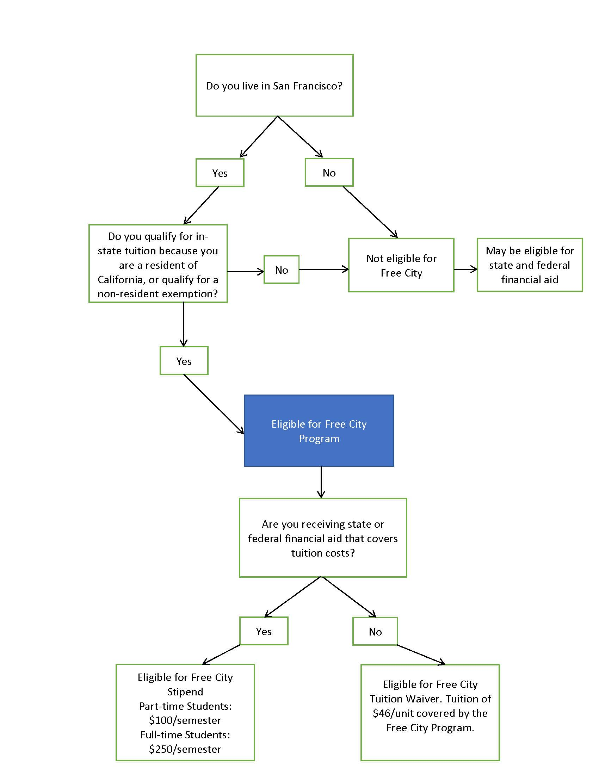

**There is a non-resident exemption for people who: attended a California high school for 3 or more years and graduated from a California high school or the equivalent (such as by earning a GED or passing the California High School Proficiency Exam); are registered to attend a California college or University (AB540, AB2000); or are a non-resident veteran (AB 13).

**C. Outreach**

**Access. Opportunity.**

**\*\****Please note that Free City funds were not used for the outreach campaign.*

City College of San Francisco launched a comprehensive outreach campaign to ensure that all San Franciscans were aware of the new Free City program at City College. The key themes of the campaign were an extension of those underlying the program itself: access and opportunity. Extensive quantitative and qualitative research built the strategic foundation for the multi-channel outreach campaign that was implemented for the Fall 2017 campaign, which focused on free tuition, and the Spring 2018 campaign, which focused on the quality of education.

This multi-channel campaign featured digital and transit advertising, extensive community outreach, and a coordinated media strategy to effectively reach the majority of the San Francisco population.

**Advertising**

The students featured in the Fall 2018 advertising campaign were current Free City College students, and represented the range of ages and ethnicities represented in the College’s enrolled student population. The majority of students at CCSF are students of color, and - while some students enroll at City College shortly after completing high school - many return to school to complete their educations or build skills much later in life. It was important for prospective students to see themselves in these ads so that they could see themselves pursuing and completing their own free education.

Because the majority of current and potential students rely on public transportation, there was a targeted muni campaign, on-bus ads, and bus shelter ads. Due to the fact that students are unlikely to be reached via broadcast or print media, the College implemented a digital campaign that emphasized social media and website advertising, search engine optimization (SEO), and search engine marketing (SEM), all of which drove potential students to a new streamlined landing page that provided more streamlined registration. However, to ensure that older generations were reached as well, there were also resources reserved for print advertisements in local neighborhood publications, handing out postcards, and placing posters in shop windows throughout the City.

**Grassroots Outreach**

Another extremely important component of the campaign included grassroots outreach. This included forming and strengthening partnerships with organizations such as the San Francisco Unified School District (SFUSD), the Community Housing Partnership, the Salvation Army, Boys and Girls Clubs, religious communities, and neighborhood business and residential organizations to spread information about Free City. The college also maintained a presence at major San Francisco events throughout the year, such as Sunday Streets, PRIDE, and rallies.

**Public Relations**

The College launched a comprehensive earned media campaign to secure coverage in local and national news publications. Because San Francisco’s Free City program was one of the first of its kind across the nation, it received a significant amount of media attention.

Include examples in the appendix of the report.

**D. Lessons Learned**

The 2017-2018 academic year was the first implementation year of the Free City College program. Building and administering a new, comprehensive program coordinated between two large institutions and between multiple organizations, departments, and points of information will almost necessarily bring unexpected challenges. Considerable resources have gone to helping the various parties gain understanding and clarity about data, administration, and common understanding of terminology and information. Due to the lessons learned from this first year of implementation, as well as the development of standard procedures for sharing data, it is anticipated that the administration of future program years will be more streamlined.

From a high level, one of the challenges related to data was that CCSF and DCYF use different language when describing data. Moving forward, terms should be clarified and opportunities should be taken to build procedures on top of already existing ones, rather than creating new or differentiated procedures.

Additionally, enhanced clarification of terms and expectations would be helpful as they relate to the terms in MOU, success measurements, and the outcomes and impacts of financial aid.

**Administration**

**Reporting**

With the creation of the Free City program, City College was given the task of developing and following a new set of reporting requirements for the local level, which necessitated the creation of a new reporting structure in addition to, and distinct from, the long-established state and federal reporting structures. The resource-intensive added reporting requirement without a corresponding addition of staff raised several challenges in the data reporting and collection process. The need exists to build a permanent infrastructure that would allow for data to be collected and reported in tandem with state and federal requirements. Given that this is a two-year pilot program, the level of resources necessary to develop such an infrastructure was not provided.

**Invoicing**

There were several challenges the City and College faced related to the invoicing process. There was no clear direction on the timing of invoices, or the information needed to verify expenses. Additionally, the invoices were either not internally consistent or did not provide the City with the information needed to verify costs.

To address these issues in future years, CCSF – as experts in its own operations - will propose a detailed plan that includes procedures and timelines for invoices. The City will work with CCSF on finalizing the data, securing the information needed for verifying costs, and finalizing an agreement surrounding invoice timing and procedures. Additionally, CCSF experts related to financial aid and institutional research will be included as participants during the planning stages.

**Fiscal Shortfall/Administration of Free City**

The costs for administering the Free City program exceeded the agreed upon funding amount. This amount was based on the information CCSF provided during policy development, and predicated on the assumption that State and Federal aid would be accessed by students before receiving Free City funding.

Moving forward, CCSF and the City should establish the clear role of State and Federal aid, as well as the resulting fiscal impacts of these programs on the Free City College program design.

**Communication/Information/Data**

The information and data that was provided by CCSF to the City was often inconsistent and could vary depending on which division was providing the information. This was in part due to the fact that clear direction was not given to the College on exactly what, or how, data should be provided, and data surrounding program outcomes were often either insufficient or internally inconsistent. The requests for data from the City also frequently changed based on the information that was being asked for.

Moving forward, the outcome measures need to be defined. CCSF and DCYF will propose a plan that includes what data should be provided, who will provide the data, and the timeline. This committee would recommend that CCSF have at least 1 FTE devoted to this program that can help communicate across divisions within CCSF, and to act as a point person between CCSF and the City. Additionally, the committee recommends developing a formalized process for collecting and sharing data.

**VI. First Year Outcomes**

A. Enrollment Outcomes

In both the Fall and Spring semesters, around 14,000 students enrolled through the Free City program. Around 67% of these students received the fee waiver, while 33% received a grant. Historically, City College enrollment dips a small amount in Spring compared to Fall.

|  |  |  |  |  |
| --- | --- | --- | --- | --- |
| **Free City Students** | **Fall 2017** | **%** | **Spring 2018** | **%** |
| Free City Fee Waiver | 9,492 | 67.8% | 9,302 | 66.5% |
| Full-Time Grant | 2,539 | 18.1% | 2,402 | 17.2% |
| Part-Time Grant | 1,970 | 14.1% | 2,283 | 16.3% |
| Total Free City Students | 14,001 |  | 13,987 |  |

This Committee was interested in making comparisons between Academic Year 2017-18 and the prior academic year. However, the data provided has been inconsistent, making it difficult to determine what the change in enrollment outcomes has been.

**Table X: San Francisco Residents Awarded California College Promise Grants (Fall 2016 vs. Fall 2017). San Francisco residents.**

|  |  |  |  |
| --- | --- | --- | --- |
| **CA Promise Grant Outcomes** | **Fall 2016** | **Fall 2017** | **% Change** |
| SF Residents Enrolled | 14,867 | 18,886 | 27% |
| CA Promise Grant | 9,608 | 6,912 | -28% |
| Free City College Waiver | N/A | 10,687 |  |
| No Free City/Promise Grant Application | 5,259 | 1,287 | -76% |

**[NOTE] The following table was in Jay’s presentation to the Committee:**



Between Fall 2017 and Fall 2016, student enrollment for San Francisco Residents grew for all course-load levels. The most significant growth was with students enrolled less than part-time (fewer than 6 units), which grew by 45%. The part-time cohort (6-11 units) grew by 25%

Full-time enrollment grew by 4%. Students taking at least 6 units are eligible for a Free City stipend.

**Table X: Student Course Load Changes**

* Growth in enrollment was due mainly to part-time students.
* In the Fall semester, Full-Time students only increased by 4.3% while part-time student growth was 36.1%.
* During the Spring semester, full-time student growth was 12.4% compared to 30.0% for part-time students.
* Much of this was driven by part-time students receiving Free City college fee waivers, which suggests that the Free City fee waiver is a larger incentive for part-time students rather than full-time students.

|  |  |  |
| --- | --- | --- |
| SF Residents Enrolled | Full-Time Growth | Part-Time Growth |
| Fall 2017 over Fall 2016 | 4.3% | 36.1% |
| Spring 2018 over Spring 2017 | 12.4% | 30.0% |

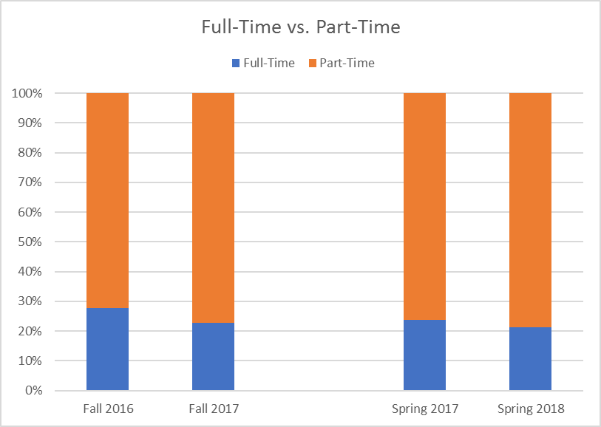

*B. Persistence / Drop Rate*

Since the implementation of Free City, the overall completion and withdrawal rates for CCSF has a whole has not changed significantly. This holds true when broken out by units enrolled. However, the Free City completion rate is slightly lower than the non-FCC population for both Fall and Spring.

**Table X: Completion Rate for Entire City College of San Francisco Student Population, Fall 2016 – Spring 2018**

*The student completion rate, or the number of students who completed their coursework,* ***increased*** *under the Free City College Program.*

|  |  |  |  |
| --- | --- | --- | --- |
| **Academic Term** | **Completion** | **Withdrawal** | **Total Enrollment Count** |
| Fall 2016-17 (pre-FCC) | 87.3% | 12.7% | 57,634 |
| Spring 2016-17 (pre-FCC) | 88.1% | 11.9% | 57,588 |
| Fall 2017-18 | 87.6% | 12.4% | 65,487 |
| Spring 2017-18 | 88.8% | 11.2% | 65,015 |

**Table X: Completion Rate for Free City College-Eligible Students to Non-Free City College Students, Fall 2017 – Spring 2018**

*FCCY refers to students who are eligible for stipends or tuition waivers through the Free City program. Not FCC refers to students who are ineligible for these benefits.*

There was no meaningful change / about the same before FCC and after FCC. This points to the fact that having free tuition does not make a student less likely to complete their education.

|  |  |  |  |  |
| --- | --- | --- | --- | --- |
| **Academic Term** | **FCCY** | | **Not FCC** | |
| **Completion** | **Withdrawal** | **Completion** | **Withdrawal** |
| Fall 2017 | 86.0% | 14.0% | 88.7% | 11.3% |
| Spring 2018 | 87.7% | 12.3% | 89.5% | 10.5% |

**Table X: Withdrawal Rates by Enrolled Units during Academic Year 2016-2017 compared to Academic Year 2017-2018**

*The student withdrawal rate, or the number of students who did not complete their coursework,* ***decreased*** *under the Free City College Program.*

|  |  |  |  |  |
| --- | --- | --- | --- | --- |
| **AY Fall and Spring** | **Withdrawal rate by units enrolled** | | | |
| **less than 6** | **6 to 9** | **9 to 12** | **12 or more** |
| 2016-17 | 14.4% | 16.1% | 15.1% | 9.3% |
| 2017-18 | 13.4% | 14.9% | 14.3% | 9.1% |

*C. Grant Outcomes*

Grants in the form of stipends for expenses are available to students who are not eligible for free tuition (please see the table on **page** **X** for more information regarding this distinction). Full-time students, defined as students who take 12 or more units, are eligible for a $250 stipend each semester. Part-time students, defined as those who are enrolled in 6-11 units, are eligible for a $100 stipend each semester.

To ensure that students are receiving the appropriate stipend related to their course loads, disbursements are made three times per semester. The first payment, which is half of the total disbursement amount, is made four weeks into the semester. The second disbursement assesses each student’s enrollment, and pays or withholds second payment according to enrollment. A payment is withheld if a student drops from a full-time course load to a part-time student, or from a part-time course load to a less than part-time course load. Otherwise, the second half of the stipend is awarded.

A third disbursement is made to students who enrolled in late start classes, and at the end of the semester, the College assesses payments made to students to determine whether or not grants need to be repaid.

Below is an overview of the students who received grants during Fall 2017 and Fall 2018. Please note that the average grant amounts for full-time students is less than $250 because some students changed from full-time to part-time status during the semester, and average grant amounts were less than $125 for part-time students because some students changed from part-time to less than part-time status.

**Table X: Total Grants (Stipends) Awarded to FCCY Students in the Fall 2017 Semester**

|  |  |  |  |
| --- | --- | --- | --- |
|  | Fall 2017 | | |
|  | Full-Time | Part-Time | Total |
| Headcount | 2,587 | 2,157 | 4,744 |
| Total Grant Amount Awarded | $620,792 | $202,250 | $823,042 |

**Table X: Total Grants (Stipends) Awarded to FCCY Students During the Spring 2018 Semester**

|  |  |  |  |
| --- | --- | --- | --- |
|  | Spring 2018 | | |
|  | Full-Time | Part-Time | Total |
| Headcount | 2,402 | 2,283 | 4,685 |
| Total Grant Amount Awarded | $596,125 | $223,100 | $819,225 |

**Table X: Total Grants (Stipends) Awarded to FCCY Students During the 2017-2018 Academic Year**

|  |  |  |  |
| --- | --- | --- | --- |
|  | Both Fall and Spring |  |  |
|  | FT | PT | Total |
| Headcount | 4989 | 4440 | 9429 |
| Total Grant Amount Awarded | 1216917 | 425350 | 1642267 |

*D. Financial Outcomes*

**Table X: Expenditure Totals**

|  |  |  |  |  |  |  |
| --- | --- | --- | --- | --- | --- | --- |
| ***Budget/Invoice*** | ***Fall 2017 Projected*** | ***Fall 2017 Actuals*** | ***Spring 2018 Projected*** | ***Spring 2018 Actual*** | ***Total Projected*** | ***Actual*** |
| *Budget* | *$2,683,476* | *$4,019,180* | *$2,683,476* | *$3,889,817* | *$5,366,952* | *$7,908,997* |
| *Staffing / Infrastructure* | *$72,878* | *$72,878* | *$264,987* | *$264,987* | *$337,865* | *$337,865* |
| ***Total Invoice*** | ***$2,756,354*** | *$4,092,058* | ***$2,948,463*** | ***$4,154,804*** | ***$5,704,817*** | ***$8,246,862*** |

**MOU Invoicing Requirements**

City College of San Francisco must complete and submit to the DCYF the funding request template laid out in Appendix B of the Free City MOU (that the entire Memorandum is included in **Appendix X** of this report). City College must also provide the DCYF with the number of credits taken by each individual FCC eligible student who received funding through the Agreement (but not their names or other identifying information); and the number of FCC eligible students who drop classes before the refund deadline, after the refund deadline, and after census with each funding request.

While the funding request provided by the College was based on the MOU format, insufficient and unclear data prevented the DCYF from being able to adequately verify the provided cost information.

**Main Takeaways**

The financial reports submitted to the DCYF, and the lack of sufficient backup data, left the Department without a clear understanding of how the college calculated its invoice costs. However, while the data was not self-explanatory, CCSF was able to answer case by case questions regarding idiosyncrasies within the data, and to explain the system constraints that resulted in some data variations.

Additional data challenges included fluctuations in headcount between invoices without clear explanation, and discrepancies between DCYF’s total cost calculations and the College’s cost calculations (although the College did provide sufficient evidence for costs exceeding the total budgeted amount, resulting in a $2.8 million payment by the City).

DCYF and CCSF are working together to better define the data requirements, as well as the invoicing format and timing.

*E. Shortfall Analysis*

**California College Promise Grant**

In Fall 2017, the expected budget for the Free City College program was $2.7 million. However, the actual cost for the semester was $4.0 million, leaving City College with a $1.3 million shortfall. The analysis in **Table X** looks at how much of the shortfall was due to a reduction in the take-up of the CA Promise Grant.

The budget was developed by City College and the City and County of San Francisco, based on enrollment estimates set by City College. The assumptions made for the budget assumed that the number of SF residents taking the CA Promise Grant would grow by 20%, while the number credits taken by non-Promise Grant students would grow by 20%.

San Francisco residents saw their enrollment increase by 27% in the first semester of the Free City College program. However, California Promise Grant enrollment fell by 28.1%. This suggests students who may qualify for the California Promise Grant are forgoing the grant and instead relying on the Free City program to cover tuition costs.

**Table X: California Promise Grant take-up Rate, Fall 2016 to Fall 2017 Comparison**

|  |  |
| --- | --- |
| **CA Promise Grant Outcomes** | **Change Between Fall 2016 and Fall 2017** |
| SF Residents Enrollment | 27.0% |
| CA Promise Grant Enrollment | -28.1% |

This committee simulated what the costs would have been had City College maintained the prior year rate of enrollment for the California Promise Grant in **Table Y** (below). This is a conservative estimate, which assumes that San Francisco residents taking the CA Promise Grant would see 0% growth.

There are two components of cost: the stipend amount given to California Promise Grant recipients, which is $250 for full-time students per semester and $100 for part-time students; and the $46 given for each credit taken by non- California Promise Grant recipients.

**Table Y: Simulated Free City Cost Assuming Consistent CA Promise Grant Take-Up Between Fall 2016 and Fall 2017**

|  |  |  |  |  |
| --- | --- | --- | --- | --- |
| **Fall 2017** | **Stipend Cost** | | **Free City Waiver** | **Total Cost** |
| **Full-Time Students** | **Part-Time Students** | **Credits** |
| Simulation: Students/Credits | 3,982 | 3,764 | 31,800 |  |
| Total Cost | $995,500 | $376,400 | $1,462,800 | $2,834,700 |

The simulation in **Table Z** shows that if CA Promise Grant take-up had remained constant between Fall 2016 and Fall 2017, the total cost of the Free City Program would have been $2.8 million, which is $1.2 million less than the costs actually incurred. The simulated cost demonstrates a $151k shortfall, which is significantly less compared to the $1.3 million shortfall City College experience in Fall 2017. This suggests that most of the shortfall can be explained by students forgoing the CA Promise Grant and instead relying on the Free City College waiver to cover their tuition.

**Table Z: Free City Cost for Fall 2017, Simulated vs. Actuals**

|  |  |  |  |
| --- | --- | --- | --- |
|  | **Total Cost** | **Budget** | **Shortfall** |
| **Simulation Cost for Fall 2017\*** | $2,834,700 | $2,683,476 | -$151,224 |
| **Fall 2017 Actuals** | $4,019,179 | $2,683,476 | -$1,335,703 |
| **Difference** | -$1,184,479 |  |  |

1. **Recommendations / Conclusions (draft)**

**[Leave one blank page]**

**Rachel: Pull some information from the Lessons Learned**

**Policy recommendations – develop after final updated data received**

* In future reports, add people who are doing job and vocational training

**Appendix [**[**See folder in Shared Drive**](https://www.dropbox.com/sh/6tvle8ktlj3thbk/AAAF6eGvgkvPcNKZjjKU-MCMa?dl=0)**]**

**Appendix 1**. Free City Resolution Approving MOU, Passed by Board of Supervisors November 14, 2017

**Appendix 2**. Free City Affidavit

**Appendix 3. Advertising Campaign**

Fall 2017 Advertising Brief

Spring 2018

Fall 2018 Project Brief

**Appendix 4.** Invoices – See Below

**Fall 2017 Invoice**

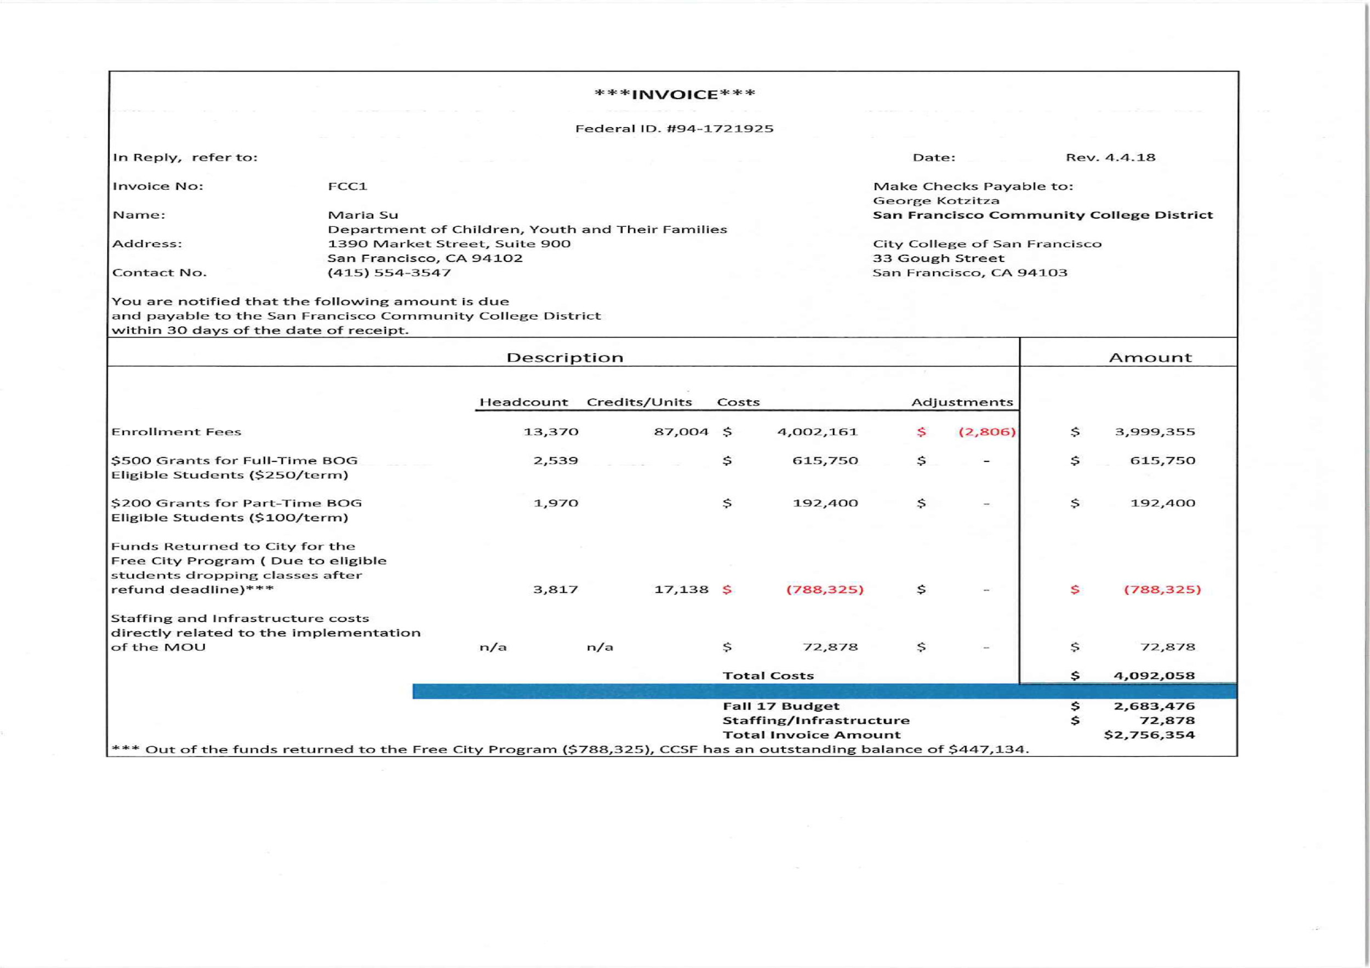

**Spring 2018 Invoice**

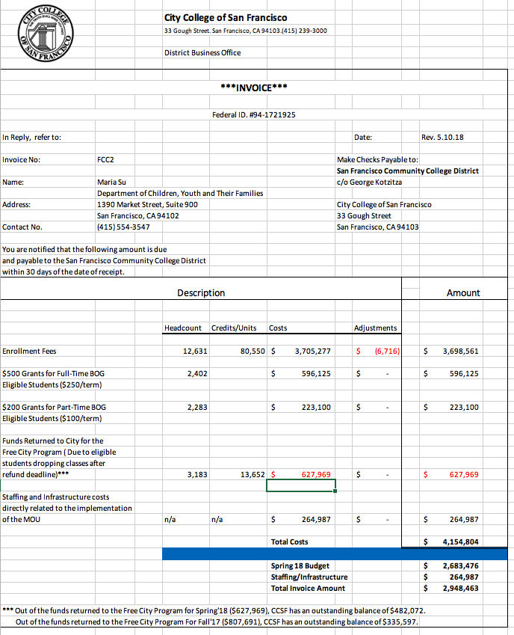

[From Jay Liao’s Total Cost v. Invoice Excel document]

**Fall 2017 Invoice**

**Invoice 1**

* First invoice received was an estimate. No information on credits was provided to confirm enrollment fee amounts.
* Headcount information did not match stipend cost information
* For example, for Full-Time BOG students, the initial enrollment count was 4,213 students. 4,213 x $250 is $1,053,250. However the Gross Cost stated in the invoice was $597,375.

|  |  |  |  |
| --- | --- | --- | --- |
| **Fall Invoice Interations** | **Invoice 1: Received 12/8/17** | | |
| **Headcount** | **Credits** | **Cost** |
| Enrollment Fees | 9,705 | N/A | $1,854,743 |
| $250 Grant for Full-Time BOG ($500 for full year) | 4,213 | N/A | $1,027,125 |
| $100 Grant for Part-Time BOG ($200 for full year) | 4,728 | N/A | $459,250 |
| Funds Returned to City for Free City Program | 4,957 | N/A | -$435,459 |
| Staffing and Infrastructure Costs |  |  | $63,935 |
| **Total Cost** |  |  | **$2,969,594** |
| Budget |  |  | $2,683,476 |
| Staffing/Infrastructure |  |  |  |
| **Invoice Amount** |  |  | **$2,969,594** |

**Invoice 2**

* Second invoice received with more backup documentation, however costs calculations were still not entirely clear.
* Calculations for enrollment fees are based on average credits per student, but this estimate cannot be verified by DCYF based on information given.
* Number of students in Invoice and the number of students used in calculations for stipend amount differs with no explanation.
* MOU requires City College to provide data on the number of credits taken by each student, and to include the number of eligible students who drop before the refund deadline, drop after the refund deadline, and after the Census. This information was not provided.

|  |  |  |
| --- | --- | --- |
| **Invoice 2: Received 1/31/18** | | |
| **Headcount** | **Credits** | **Cost** |
| 7,315 | N/A | $2,624,622 |
| 2,048 or 3,803 | N/A | $950,750 |
| 5,266 or 9,780 | N/A | $978,000 |
| 3,847 | N/A | -$798,238 |
|  |  | $69,947 |
|  |  | **$3,825,081** |
|  |  | $2,683,476 |
|  |  |  |
|  |  | **$3,825,081** |

**Invoice 3**

* In third invoice, enrollment fee calculations are shown to be based clearly on total credits, but an adjustment column is added, which adjusts headcount rather than credits, making it unclear how final cost is calculated.
* Grant amounts are unclear. Headcount still does not match stipend cost information, no clarity on how cost is calculated.

|  |  |  |
| --- | --- | --- |
| **Invoice 3: Received 2/15/18** | | |
| **Headcount** | **Credits** | **Cost** |
| 10,564 | 87,004 | $3,999,355 |
| 2,587 | 33,545 | $620,792 |
| 2,157 | 15,767 | $202,250 |
| 3,817 | 17,138 | -$788,325 |
|  |  | $72,878 |
|  |  | **$4,106,950** |
|  |  | $2,683,476 |
|  |  |  |
|  |  | **$4,106,950** |

**Invoice 4**

Final invoice methodology matches third invoice, so enrollment costs and grant amounts not verifiable

DCYF did not agree to the total cost amount, but determined that there was sufficient evidence of costs exceeding the total budgeted amount that the payment for $2.8 million was made.

|  |  |  |
| --- | --- | --- |
| **Invoice 4: Received X/XX/18** | | |
| **Headcount** | **Credits** | **Cost** |
| 10,564 | 87,004 | $3,999,355 |
| 2,539 |  | $615,750 |
| 1,970 |  | $192,400 |
| 33,817 | 17,138 | -$788,325 |
|  |  | $72,878 |
|  |  | **$4,092,058** |
|  |  | $2,683,476 |
|  |  | **$72,878** |
|  |  | **$2,756,354** |

**Spring 2018 Invoice**

|  |  |  |  |
| --- | --- | --- | --- |
| **Spring Invoice** | **Received XX/X/18** | | |
| **Headcount** | **Credits** | **Cost** |
| Enrollment Fees | 5,915 | 80550 | $3,698,561 |
| $250 Grant for Full-Time BOG ($500 for full year) | 2,402 |  | $596,125 |
| $100 Grant for Part-Time BOG ($200 for full year) | 2,283 |  | $223,100 |
| Funds Returned to City for Free City Program | 3,183 | 13652 | -$627,969 |
| Staffing and Infrastructure Costs |  |  | $264,987 |
| **Total Cost** |  |  | **$4,154,804** |
| Budget |  |  | $2,683,476 |
| Staffing/Infrastructure |  |  | **$264,987** |
| **Invoice Amount** |  |  | **$2,948,463** |
|  |  |  |  |
|  |  |  |  |
| Spring Invoice matches methodology of final Fall Invoice. |  |  |  |

1. Since this research, much more has been written about how promise programs do too little to support low-income, first-generation, and students of color. (Could add references here?) By increasing aid to low-income students, however, Free City largely avoids this critique even while making higher education universally accessible for San Francisco residents.