Free City Annual Report
[Cover Page]

Version:
July 8, 2019

Table of Contents
- Executive Summary
- Letter from Jane Kim
- Introduction and Purpose
  - Glossary
- Impact to the City and Students
  - Student Enrollment and Participation Outcomes
  - Student Demographics
  - Enrollment by Zip Code
- Administration of Free City College
  - MOU Summary
  - Administration
  - Outreach
- First Year Outcomes
  - Enrollment Outcomes
  - Persistence and Drop Rates
  - Grant Outcomes
  - Financial Outcomes
  - Shortfall Analysis
  - Lessons Learned

- Recommendations and Conclusions
- Appendices (list?)

- Executive Summary

Hold one complete page for executive summary

Include the context of the report – i.e. credit students only, academic year 2017 – 2018

Answer the questions:
- How many individual students has FC served? (more than 22,500 in first year)
- How much does the program actually cost? ($7.9M annually, excluding adminstration and staffing costs)

- Statement from Supervisor Jane Kim

In the 20th century, America made an expensive choice—we determined that a K-12 public education was fundamental to our citizenry and a workable nation, and that this public education should be free and universal.

It used to be that many good-paying jobs only required a high school diploma, and that this diploma was enough to give most Americans an opportunity to climb into the middle class. However, in the last 30 years, innovation and technology has raced ahead of our public education system.

Now research shows that by 2020, 70% of all jobs will require some type of post-secondary degree, training or certificate. Politicians are taking note. In 2015, President Obama proposed a plan to make community college free for all Americans for two years. States like Oregon, Minnesota, and Tennessee implemented a variety of programs to make community college free for eligible high school students. We studied and learned from these programs when developing the #FreeCity policy in 2016.

We learned that tuition-free programs did not necessarily incentivize the enrollment of low-income students because other costs such as books, childcare, and transportation exceeded the cost of classes. We also learned that requiring students to enroll full-time in order to be eligible for tuition-free programs exclude individuals who simply must work while attending classes. Many promise programs also exclude those who are not recent high school graduates but wanted to upskill, switch careers, or get their associates degrees later in life.

Community colleges are our only life-long learning institutions. As such, it’s important that we now think of access to higher education as we consider access to K-12 public education. As policy makers, it is our responsibility to examine and RE-examine the tools and resources we consider fundamental to our citizens in order to provide all people a fighting chance to be productive members of our society.

40 years ago, middle-class Americans outnumbered Americans in either the low income or upper income bracket. Now, those who are either low-income or upper-income outnumber Americans in the middle class. The Brookings Institution found that the income gap between San Francisco's rich and poor is growing faster than in any other city in the nation. No one can deny this growing inequality-- we don't need to agonize over the data, we see it on our streets.

We are responsible for at least trying to reverse this trend.

There is no better way of doing this than investing in our citizens, investing in their education, and raising their likelihood of succeeding in our region.

San Francisco has a legacy of being bold and progressive. We are one of the first cities to marry gay couples, establish universal health care, and raise the minimum wage of ALL of our workers to $15/hour. In 2016, San Francisco voters passed our initiative to raise revenue to make City College free. I am proud to have played a leadership role in making San Francisco the ONLY city in the nation to make community college free to all our residents, regardless of income, age, or a GPA pre-requisite.

San Francisco has the opportunity - and perhaps, even the responsibility - to play a leadership role in a national dialogue about how we can best invest in our citizens to ensure they succeed. San Francisco is one of the wealthiest cities in the world, which means we can afford to enact dream policies, demonstrate how these policies should work, and measure their outcomes.

And organizers, community leaders and elected representatives around the state and the country have taken note. New York announced tuition-free state college for full time students, and California passed legislation making community college free for the first year. I am excited that Governor Newsom has proposed making community college free for two years. And Delaware, Hawaii, Washington, Rhode Island, Montana, and Nevada have implemented some type of tuition assistance program to make public college more accessible and affordable for their residents as well.

This is the first annual report (of many!) presenting the data and outcomes of Free City’s first year of implementation. Thank you to the team of City College of San Francisco faculty, students and administrators; the San Francisco Controllers Office and Department of Children, Youth and their Families; and Mayor Edwin Lee and London Breed’s office for your collaborative work to implement this program and assemble this report.

Finally, I want to recognize and thank AFT 2121 and the San Francisco Labor Council - as well as the broader coalition including the CCSF Solidarity Committee, Community Housing Partnership, and Jobs With Justice - for their leadership, research, advocacy, and partnership with our office to make City College free.

Sincerely,

Jane Kim

[Electronic Signature Needed] - Aliya

- Introduction and Purpose

THIS SECTION CAN BE FOUND IN A SEPARATE DOCUMENT. PLEASE MAKE ALL CHANGES TO THIS SECTION IN THAT SEPARATE DOCUMENT.

GLOSSARY of TERMS
MOU - Memorandum of Understanding entered between the City and County of San Francisco and the San Francisco Community College District
DCYF - Department of Children, Youth, and their Families - the City department charged with the Free City program, including oversight of the fund and paying invoices submitted by the College

CCSF - City College of San Francisco (also referred to as the San Francisco Community College District)

The City – City and County of San Francisco

CCPG Waiver (Formerly Known As BOG) - the California College Promise Grant, state financial aid that covers the cost of tuition. Known until recently as the California Community College Board of Governors Fee Waivers or BOG.

FCCW - Free City College Waiver, which refers to the tuition assistance provided by the city to cover the cost of enrollment fees.

FCC - Free City College, the program enacted by the city to cover enrollment fees or stipends to residents of San Francisco.

FAFSA - Free Application for Federal Student Aid

Free City College Grant - This refers to the $250 per semester for full-time students or the $100 stipend for part-time students.

DREAM Act - Legislation that allows undocumented, DACA, or temporary protected status students to apply for state financial aid.

AB540 – Exempts certain students from paying nonresident tuition and allows them to apply for different types of California Dream Act financial aid.

AB13 – Exempts veterans from paying nonresident tuition.
AB19 – A statewide 2018 bill that provides funding to community colleges to support first-time full-time college students.

Non-Resident Tuition – For out of state and international students, the 2017 – 2018 academic year cost is $257/unit

California Resident Tuition - $46/unit

Full-Time Student – At CCSF, defined as student enrolled in 12 or more units

Part-Time Student – At CCSF and for Free City, defined as a student enrolled in 6-11 units. This cohort includes 3/4-Time students (defined as a student enrolled in 9-11.5 units) and Half-Time students (defined as a student enrolled in 6-8.5 units).
IV. Impact to the City and Students

- Enrollment Outcomes

The Free City program creates an opportunity for San Francisco residents who otherwise would not have been able to afford to attend college. CCSF experienced its first meaningful enrollment increase in over a decade and saw enrollment grow dramatically between Academic Year 2016-17 and the first year of Free City implementation in 2017-18. During this period, enrollment of credit students residing in San Francisco grew from 24,833 students to 30,431 students, marking a 22.3% increase. More students enrolled at City College because of the Free City program, which served 22,510 students during the first two semesters of the 2017-18 Academic Year. (See Appendix X How Students are Counted)

<Might be good to talk about some survey anecdotes here>

Source: City College of San Francisco—Institutional Research

- Enrollment Demographics – Race / Ethnicity, Age, Zip code

Between the 2016-2017 and 2017-2018 academic years, the college saw growth across every race/ethnicity category, age category, and even across every zip code. The broad-based growth also meant that there was no statistically significant demographic shift in the overall student population.

The broad-based growth and demographic outcomes hold true when looking specifically at the Free City student population. When using the San Francisco credit student population from prior years as a point of comparison, we see broad-based growth across all demographic categories with little change to proportional representation. Like the prior year San Francisco credit student population, the Free City population is mostly Asian, White, and Latino. When compared to non-Free City students, the population tends to be older and more educated. Geographically, enrollment grew across all neighborhoods in San Francisco. Ingleside-Excelsior and Crocker-Amazon hold the largest proportion of Free City students. Mission Bay, while a small part of the student population, saw the largest growth in enrollment since the Free City program was implemented.

Chart X: Race / Ethnicity Breakdown for FCC Students

City College saw growth across all race/ethnicity categories for all credit students between Academic Years 2016-17 and 2017-18, the highest growth rates coming from Pacific Islander, White, and Filipino students. Given the broad-based growth, the proportions across race/ethnicity categories did not shift significantly. Asians remain the largest proportion of students at the college with 29.4% of the student population followed by Latino and White students who make up 25.0% and 24.4% respectively.

In Chart X, San Francisco credit students from Academic Year 2016-17 were used as a point of comparison against the Free City population to analyze any possible impact the program may have had on the race/ethnicity breakdown. The Free City race/ethnicity breakdown looks similar to the prior year San Francisco credit student population. Asian students are the largest proportion of students taking up the Free City program with 30.9% of the Free City population followed by White and Latino students who make up 26.0% and 24.2% respectively.

Source: City College of San Francisco—Institutional Research

Table / Image X: Breakdown of Students by Age

Student credit enrollment for San Francisco residents saw growth across all age categories. While growth was broad-based, age categories over 30 years old saw higher growth rates averaging 24.4% growth compared to students under 30 who averaged 9.8% growth.

The age distribution for Free City students takes on a similar shape to non-Free City students. Students ages 20-24 make up the largest proportion of Free City students with 24.5%. Students 30 and older make up a higher proportion of the Free City student population than the non-Free City student population. In effect, this makes Free City students on average, older than the rest of the City College student population. There is also a larger proportion of degree-holding students, reflecting a higher number of students returning to school for retraining and lifelong learning. <Need reference for this>

Source: City College of San Francisco-Institutional Research

Table / Image X: Geographic Distribution of Students by District, Academic Year 2017-2018 (Display as a Map)

Enrollment increased across all San Francisco zip codes indicating that Free City had an impact city-wide. Again, this broad-based growth meant that proportions across zip codes and neighborhoods did not change significantly. There are 5,032 credit students from the Ingelside-Excelsior/Crocker-Amazon neighborhoods making it the area with the largest proportion of San Francisco credit students at 16.6% of the population. As the map below shows, the student population tends to be concentrated in the southern part of the City as well as the Sunset.

While growth was seen across the City, some neighborhoods saw larger growth rates. Mission Bay residents, while a small portion of the student population, saw the highest growth with a 44.4% increase. Haight-Ashbury/Cole Valley, Embarcadero South, Castro/Noe Valley, South of Market, and Potrero Hill all saw growth rates above 30%.

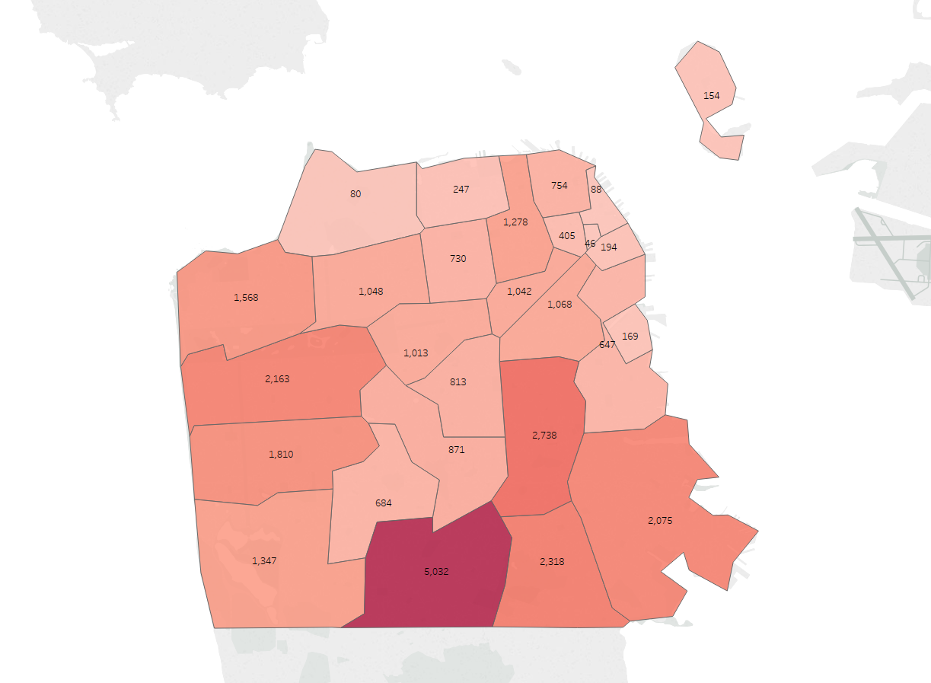
V. Administration of Free City College

- MOU Summary

On November 14, 2017, the San Francisco Board of Supervisors ratified a Memorandum of Understanding (MOU) between the City and County of San Francisco (represented by the Department of Children, Youth, and their Families) and the San Francisco Community College District (City College of San Francisco). This program, called Free City, was to use City funds to provide San Francisco residents with free access to college through the form of waived enrollment fees or stipends for additional educational expenses. The college committed to a good faith effort to get students to use state and federal financial aid. Students are encouraged to access financial aid, and additional Free City stipends are only available to students who first utilize state financial aid.

The key components of the pilot agreement were as follows:

Term Length – July 1, 2017 - June 30, 2019 (2 years)
Funding – The maximum amount allocated by the city for spending on the pilot program is $11,233,904 for two academic years, which includes the allocation of $500,000 to cover the costs of the college’s program administration. Funding excludes Summer sessions.

Benefits: A summary of benefits through the program are as follows:

- Free City covers tuition fees for SF residents who qualify for in-state tuition ($46/unit for credit courses), regardless of age, previous educational experience or attainment, course load, or course of study,
- For students whose tuition fees are covered by state or federal financial aid, supplemental Free City-funded aid is offered for educational expenses: for full-time students (12 or more units), a $250 per semester stipend, and for students taking 6-12 units, a $100 stipend per semester.
- Students who drop classes after the refund deadline (a couple of weeks into the semester) are expected to repay the cost of tuition but are otherwise eligible to access the program again in future semesters.

Free enrollment for San Francisco residents who are not eligible for state or federal financial aid (such as FAFSA), the DREAM Act, or CCPG waivers), OR additional aid for students who are receiving state or federal financial aid or fee waivers in the form of stipends at $250/semester for full-time students (12+ units) and $100/semester for part-time students (6-11 units).

Student Application Process – Students are determined to be eligible for Free City during the application process based on their reported address. Students are referred to the financial aid office in order to access stipends.

Payment from the City – City College will submit quarterly invoices to the Department of Children, Youth, and their Families (DCYF), which will make disbursements to City College within 30 days.

Oversight Committee – An oversight committee was established to meet at least once every three months and prepare annual reports on program implementation. The committee consists of 11 appointed members, which are made by the following bodies: three by the CCSF Board of Trustees, two faculty by the City College Academic Senate, one student by the Associated Students Executive Council, two by the Board of Supervisors, one by the San Francisco Unified School District Board of Education, one by the Mayor, and one by the Controller’s office.

B. Administration
Student Application Process

Students who apply for the Free City College first register online to attend City College, and then complete the Free City affidavit (see Appendix X). Based on their responses, the next screen provides information as to whether or not the student has been deemed eligible for Free City College tuition waivers or stipends. Students are not required to determine whether or not they are eligible for other forms of financial assistance, but the College agreed to make a good faith effort to get students to apply for state and federal financial aid.

In the next step, students sign up for classes and are sent to a payment screen. If a student is eligible for tuition waivers, there will be no enrollment balance due on the payment screen. If the student is already in the City College database as a financial aid recipient for programs such as FAFSA or the DREAM Act, or receives a CCPG waiver, the screen lets the student now they are eligible for a stipend. The stipend amount is based on the student’s unit load. Those students who are ineligible for Free City and financial aid charged tuition fees.
When students apply for financial aid after enrollment fees have been waived through Free City, the Bursar's Office adjusts the student’s account to ensure that the state of California covers the enrollment fees rather than the City.

Image / Chart X: Free City Program and Financial Aid Program Eligibility

The following chart demonstrates how City College of San Francisco determines whether or not a student is eligible for tuition fee waivers or stipends.

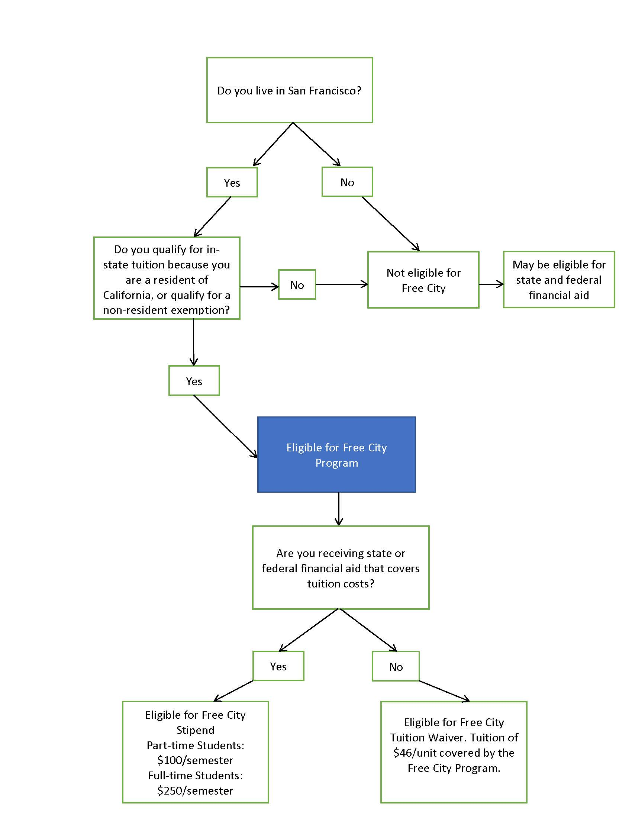

**California law provides in-state college tuition through non-resident exemptions for undocumented students meeting certain qualifications (AB540, AB2000) or for students who are non-resident veterans (AB 13).

C. Outreach

Access. Opportunity.

City College of San Francisco launched a comprehensive outreach campaign to ensure that all San Franciscans were aware of the new Free City program at City College. The key themes of the campaign were an extension of those underlying the program itself: access and opportunity. Extensive quantitative and qualitative research built the strategic foundation for the multi-channel outreach campaign that was implemented for the Fall 2017 campaign, which focused on free tuition, and the Spring 2018 campaign, which focused on the quality of education.

This multi-channel campaign featured digital and transit advertising, extensive community outreach, and a coordinated media strategy to effectively reach the majority of the San Francisco population.

Advertising
The students featured in the Fall 2018 advertising campaign were current Free City College students, and represented the range of ages and ethnicities represented in the College’s enrolled student population. The majority of students at CCSF are students of color, and - while some students enroll at City College shortly after completing high school - many return to school to complete their educations or build skills much later in life. It was important for prospective students to see themselves in these ads so that they could see themselves pursuing and completing their own free education.

Because the majority of current and potential students rely on public transportation, there was a targeted muni campaign, on-bus ads, and bus shelter ads. Due to the fact that students are unlikely to be reached via broadcast or print media, the College implemented a digital campaign that emphasized social media and website advertising, search engine optimization (SEO), and search engine marketing (SEM), all of which drove potential students to a new streamlined landing page that provided more streamlined registration. However, to ensure that older generations were reached as well, there were also resources reserved for print advertisements in local neighborhood publications, handing out postcards, and placing posters in shop windows throughout the City.

**Please note that Free City funds were not used for the outreach campaign.

Grassroots Outreach
Another extremely important component of the campaign included grassroots outreach. This included forming and strengthening partnerships with organizations such as the San Francisco Unified School District (SFUSD), the Community Housing Partnership, the Salvation Army, Boys and Girls Clubs, the San Francisco Labor Council and affiliated unions, religious communities, and neighborhood business and residential organizations as well as community groups to spread information about Free City. The college also maintained a presence at major San Francisco events throughout the year, such as Sunday Streets, PRIDE, and rallies.

Public Relations
The College launched a comprehensive earned media campaign to secure coverage in local and national news publications. Because San Francisco’s Free City program was one of the first of its kind across the nation, it received a significant amount of media attention.

Include examples in the appendix of the report.

VI. First Year Outcomes

A. Enrollment Outcomes
The Free City program is comprised of two main components. The first component is the tuition fee waiver, which covers all San Francisco residents. The second component is the stipend amount, which is only applicable to students who already have their tuition covered through the CA Promise Grant. The stipend amount is determined by a student’s full-time or part-time status.

The Free City program accounted for 17,879 students enrolled in Fall 2017, and 17,316 students enrolled in Spring 2018. Between 73% and 75% of these of these students received the fee waiver, while the remainder received stipends. Historically, City College enrollment dips a small amount in Spring compared to Fall.

Free City Students | Fall 2017 | % | Spring 2018 | %
Free City Fee Waiver | 13,370 | 74.8% | 12,631 | 72.9%
Full-Time Stipend | 2,539 | 14.2% | 2,402 | 13.9%
Part-Time Stipend | 1,970 | 11.0% | 2,283 | 13.2%
Total Free City Students | 17,879 |  | 17,316
Source: City College of San Francisco-Financial Aid

Table X: Full-Time vs. Part-Time Enrollment // Unit Load

Since the implementation of Free City college, both the number of full-time and part-time students saw enrollment growth. However, the growth in part-time students outpaced the growth in full-time students. Students taking five or fewer credits grew by 45.2% and 35.5% in Fall 2017 and Spring 2018 respectively, while students taking a full-time course-load grew by 4.3% and 12.4% during the same period.

Year-over-Year Growth | 12+ Credits | 6-11 Credits | 0-5 Credits
Fall 2017 over Fall 2016 | 4.3% | 25.7% | 45.2%
Spring 2018 over Spring 2017 | 12.4% | 23.1% | 35.5%
Source: City College of San Francisco—Financial Aid

The higher growth in part-time students has shifted the proportion of full-time students being served by the college. The proportion of full-time students fell from 27.7% to 22.7% during the Fall semester, while the Spring semester saw a smaller shift from 23.7% to 21.2%.

B. Persistence / Drop Rate

Data from the first year of Free City implementation counters the concern that students may not take their courses seriously if they don’t have to pay. When compared to prior year completion and withdrawal rates, there were no significant changes to the college as a whole in Academic Year 2017-18 with the reversal of tuition fees for San Franciscans. The data also shows that students enrolled in more full-time coursework were most likely to complete coursework. When looking at Free City students specifically, we see that they are slightly less likely to complete a course than non-Free City students, with a larger distinction in the first semester of the program.

Table X: Completion Rate for Entire CCSF Student Population, Fall 2016 – Spring 2018

Free City did not impact the completion / withdrawal rates for the college as a whole. The completion rate for Fall 2017 and Spring 2018 were 87.6% and 88.8% respectively. In both semesters, these completion rates are marginally higher than the prior year.

Academic Term | Completion | Withdrawal
Fall 2016 (pre-FCC) | 87.3% | 12.7%
Spring 2017 (pre-FCC) | 88.1% | 11.9%
Fall 2017 | 87.6% | 12.4%
Spring 2018 | 88.8% | 11.2%
Source: City College of San Francisco-Institutional Research

Table X: Withdrawal Rates by Enrolled Units during 2016-17 and 2017-18

When looking at withdrawal rates broken out by units enrolled, the data shows marginal declines in withdrawal rates during the Free City College program when compared to the prior year. Notably, full-time students (12 or more units) remained the least likely group to withdraw from their courses.

Course Load  Fall and Spring | Withdrawal rate by units enrolled
 | less than 6 | 6 to 9 | 9 to 12 | 12 or more
2016-17 (pre-FCC) | 14.4% | 16.1% | 15.1% | 9.3%
2017-18 | 13.4% | 14.9% | 14.3% | 9.1%
Source: City College of San Francisco-Institutional Research

Table X: Completion Rate for Free City and Non-Free City Students, 2017 –2018

Though overall drop rates were down (see Table X, above), students receiving Free City waivers or stipends were slightly more likely to drop a course. While increased enrolment from Free City has not led to an identifiable trend in “non-serious” students, current policy in the MOU seeks to recoup funds from Free City students who drop after the state deadline, which may have impacts on some low-income students.

Academic Term | Free City |  | No FCC
 | Completion | Withdrawal | Completion | Withdrawal
Fall 2017 | 86.0% | 14.0% | 88.7% | 11.3%
Spring 2018 | 87.7% | 12.3% | 89.5% | 10.5%
Source: City College of San Francisco-Institutional Research

D. Financial Outcomes/Shortfall Analysis
The budget as projected in the MOU for the Free City College Program for Academic Year 2017-18 was approximately $5.4 million when excluding staffing costs. The actual cost of the program was $7.9 million, leaving the College with a $2.5 million shortfall. The main factor for this shortfall was the higher than expected cost of providing the tuition waiver (-$4.2 million). This was offset by a lower than expected cost of providing the stipend ($1.6 million).

Table X Shortfall Summary
 | Free City Waiver | Full-Time stipend | Part-Time stipend | Total Cost (excl Staffing)
Projected in MOU | $2,092,632 | $1,578,000 | $1,696,320 | $5,366,952
Actual | $6,281,622 | $1,211,875 | $415,500 | $7,908,997
Difference | -$4,188,990 | $366,125 | $1,280,820 | -$2,542,045
Source: City College of San Francisco-Financial Aid

The budget was developed by City College and the City and County of San Francisco, based on enrollment estimates for the Free City program set by City College. These estimates were based on two major assumptions: 1) credits taken would grow by 20% and 2) students enrolled with the CA Promise Grant (CCPG) would grow by 20%. The CCPG was considered as part of the budgeting assumptions because it waives enrollment fees at community colleges for eligible students. In contrast, other forms of financial aid such as the Pell Grant may be used towards enrollment fees and education-related costs. As a result, the City assumed that a proportion of students at City College will qualify for the CCPG and thus have their tuition covered by the State rather than through the Fee City program. Recipients of the CCPG instead receive a stipend from the Free City program, a smaller amount than the cost of part-time and full-time tuition fees.

The first assumption was a vast underestimate and the number of credits taken actually grew by 260% instead of 20%. The second assumption turned out to be a large overestimate due mainly to a data error as well as a decline in number of students receiving CCPG. The next two sections explore why the budget underestimated the cost of the tuition waiver, and why it overestimated the cost of the stipend.

Free City Waiver Costs

The Free City Waiver covers the $46 per credit fee for all San Francisco residents. Had the program been in effect in Academic Year 2016-17, around 37,910 credits would have been covered by the Free City waiver. The MOU assumed that the College would see a 20% increase in the number of credits taken between Academic Year 2016-17 and 2017-18. However, the number of credits taken actually grew by 260%.

 | Enrollment Fee Credits
Academic Year 2016-17 | 37,910
Academic Year 2017-18 | 136,557
Growth Rate | 260%
Source: City College of San Francisco-Financial Aid

As Table X below shows, the 20% increase as projected in the MOU underestimated the actual number of credits taken by 91,065 credits. This translates into a $4.2 million shortfall in budgeted versus actual costs.

Academic Year 2017-18 | Enrollment Fee Credits | Cost (millions)
Actuals | 136,557 | $6.3
Projected in MOU | 45,492 | $2.1
Difference | 91,065 | $4.2
Source: City College of San Francisco-Financial Aid

Free City Stipend Costs

Stipends for expenses are available to San Francisco residents who already have their tuition covered by the State through the CA Promise Grant. Full-time students, defined as students who take 12 or more units, are eligible for a $250 stipend each semester. Part-time students, defined as those who are enrolled in 6-11 units, are eligible for a $100 stipend each semester.

 | Full-Time | Part-Time | Total
Headcount | 4,989 | 4,440 | 9,429
Total Grant Amount Awarded | $1,211,875 | $415,500 | $1,627,375
Source: City College of San Francisco-Financial Aid

Table X shows that the headcount came in 732 lower than anticipated for full-time grantees and 6,405 lower than anticipated for part-time grantees. This translates into a surplus of $1.7 million in Free City Grant costs.

 | FT Headcount | FT Cost | PT Headcount | PT Cost | Total Cost
AY 2017-18 Actuals (Annual Equiv) | 2,424 | $1.2 | 2,078 | $0.42 | $1.6
MOU (Assumed 20% growth) | 3,156 | $1.6 | 8,482 | $1.70 | $3.3
Difference | -732 | -$0.4 | -6,405 | -$1.28 | -$1.7
Source: City College of San Francisco-Financial Aid

Free City stipend costs came in below expected for two reasons. First, the intent of the MOU was to project 20% growth in enrollment of CA Promise Grant students who live in San Francisco over Academic Year 2016-17. However, the 20% growth was applied to a headcount that included both CA Promise Grant students living in and outside of San Francisco. Applying the 20% growth rate to the larger, incorrect base meant that the projection in the MOU would be an overestimate of students receiving the Free City Grant.

Second, when looking at actual growth rates in CCPG, we find that the number of students receiving the grant actually fell by -3.3% and -1.9% in the Fall and Spring semesters respectively. Even if the correct base were used in the budget, the estimate would still have been overstated because instead of growing by 20%, the number of students receiving CCPG actually declined.

This decline in CCPG recipients stands out in light of the fact that the number of students enrolled grew by 27.3% and 25.9% during the Fall and Spring semesters respectively. The number of CCPG recipients has been declining over the last decade, mirroring the declining enrollment numbers with City College, but may also be attributable to State changes to eligibility and application procedures. However, during the first year of implementation, enrollment numbers increased, while CCPG continued to decline. One possible explanation is that students are taking the Free City tuition waiver in lieu of applying for CCPG.

 | Fall 2016 to Fall 2017 Growth | Spring 2017 to Spring 2018 Growth
San Francisco Residents Enrolled | 27.30% | 25.90%
SF Residents Receiving CCPG | -3.30% | -1.90%
Source: City College of San Francisco-Financial Aid

e. Lessons Learned

The 2017-2018 academic year was the first implementation year of the Free City College program. Building and administering a new, comprehensive program coordinated between two large institutions and between multiple organizations, departments, and points of information will almost necessarily bring unexpected challenges. Considerable resources have gone to helping the various parties gain understanding and clarity about data, administration, and common understanding of terminology and information. Lessons learned from implementation of the pilot, as well as the development of standard procedures for sharing data, will streamline administration of future program years.

From a high level, one challenge related to data was that CCSF and DCYF use different language when describing data. Moving forward, terms are be clarified and further opportunities will be taken to build procedures on top of already existing ones, rather than creating new or differentiated procedures. DCYF and CCSF are working together to better define the data requirements.

Enhanced clarification of terms and expectations will be helpful as they relate to the terms in MOU, success measurements, and the outcomes and impacts of financial aid.

Administration

Reporting

With the creation of the Free City program, City College was given the task of developing and following a new set of reporting requirements for the City, which necessitated the creation of a new reporting structure in addition to, and distinct from, the long-established state and federal reporting structures. The addition of a new, resource-intensive reporting requirement without a corresponding addition of staff raised several challenges in the data reporting and collection process. The need exists to build a permanent infrastructure that would allow for data to be collected and reported in tandem with state and federal requirements. However, given that this is a two-year pilot program, the level of resources necessary to develop such an infrastructure were not provided. Additionally, the data varies based on where it is housed and the date on which it is pulled. To ensure data consistency, the College and the City should decide on a specific point in time on which all data will be pulled. This will address many of the issues outlined below.
Invoicing
There were several challenges the City and College faced related to the invoicing process. The initial MOU provided no clear direction on the timing of invoices, or the information needed to verify expenses. Additionally, the invoices were either not internally consistent or did not provide the City with the information needed to verify costs.

Fluctuations in headcount between invoices were not accompanied by clear explanation, and there were initial discrepancies between DCYF’s total cost calculations and the College’s cost calculations (although the College did provide sufficient evidence for costs exceeding the total budgeted amount, resulting in a $2.8 million payment by the City).

Financial reports submitted to the DCYF, and the lack of sufficient backup data, left the Department without a clear understanding of how the college calculated its invoice costs. Even though the data was not self-explanatory, however, CCSF was able to answer case by case questions regarding idiosyncrasies within the data, and to explain the system constraints that resulted in some data variations.

Fiscal Shortfall/Administration of Free City
The costs for administering the Free City program exceeded the agreed upon funding amount. This amount was based on the information CCSF provided during program development, and predicated on the assumption that State and Federal aid would be accessed by students. Further work, primarily internal to the college, is already underway to support additional student access to financial aid.

Communication/Information/Data
Because of how internal data is tracked by the College, data provided by CCSF to the City was often inconsistent based on when the data was pulled and could vary depending on which division was providing the information. An additional challenge was posed by a lack of clear direction to the College regarding exactly what, or how, data should be provided. The parameters of the City’s data requests were sometimes unclear and frequently changed.

Moving forward, the outcome measures and points of evaluation need to be better defined. CCSF and DCYF will propose a plan that includes what data should be provided, who will provide the data, and the timeline. This committee recommends that the College have at least 1 FTE devoted to this program that can help communicate across divisions within CCSF, and to act as a point person between CCSF and the City. Additionally, the committee recommends developing a formalized process for collecting and sharing data.

Evaluation
No clear parameters for data collection or overall evaluation were set up in the early stages or prior to program implementation. Given the program’s distinct design and large number of students accessing the program, the College and City could work with educational researchers to study both short- and long-term impacts.

- Recommendations / Conclusions (draft)

Conclusion
In 2017, San Francisco became the first and only city in the nation to offer free tuition to all of its residents, and those with non-resident exemptions, at the City College of San Francisco. This effort was spearheaded by former Supervisor Kim AFT 2121, and the San Francisco Labor Council and revenue was generated for the program through Proposition W, a real estate transfer tax on properties sold with a value of $5 million or higher. Overall, the program had a positive impact on the San Francisco community and at the community college.

In its first year of implementation, the college experienced the largest increase in enrollment, both in part-time and full-time students, that the institution had seen in over a decade. In terms of demographics, there was not a significant change in the overall student population at CCSF. Notably, each zip code in San Francisco had an enrollment increase, the highest being mission bay. The comprehensive outreach campaign and grassroots outreach that was funded separately by the institution may have contributed to this success.

The Free City program is unique because it offers free tuition for San Francisco residents regardless of income, age, or a GPA pre-requisite. Additionally, students who qualify for the CCPG, all of whom are low-income students, qualify for additional funds through the Free City program.

For the student population as a whole, there was no meaningful change in drop or completion rate. When broken down further, Free City students were slightly more likely than non-Free City students to withdraw from a class, but more data is needed in order to determine whether or not tuition-free students are less likely to complete their studies.

The budget as projected in the MOU for the Free City College Program for Academic Year 2017-18 was approximately $5.4 million when excluding staffing costs. The actual cost of the program was $7.9 million, leaving the College with a $2.5 million shortfall. [Include language from updated Shortfall Analysis section].

As with the implementation of any new program, Free City experienced several issues in the implementation process, specifically due to greater than expected costs coupled with a lack of clear expectations established early on for data and program goals by the City and the institution. The issue of whether FAFSA should be required for students for the Free City Program, was often a sticking point for in the oversight committee, primarily due to a lack of clarity in the MOU.

The City and the College are dedicated to the long-term availability of the Free City Program. Based on findings from the two-year pilot program, Mayor London Breed has provided funding to the institution to address the shortfall and extend Free City for the next decade.

Recommendations

Recommendation 1: Set clear expectations and goals early on.
- Data: Set clear data goals and expectations before the program is implemented.
  - A longer period of time between program ratification and implementation. This will allow the academic institution to develop the appropriate data infrastructure so that the relevant data can be tracked and reported.
- Goals: Determine clear program goals to ensure the program can be modified in order to best serve those goals.
- Establish clear roles of the oversite committee.

Recommendation 2: Engage the stakeholders who will be implementing the program to ensure smooth program implementation.

Appendix [See folder in Shared Drive]

Appendix 1. Free City Resolution Approving MOU, Passed by Board of Supervisors November 14, 2017

Appendix 2. Free City Affidavit

Appendix 3. Advertising Campaign

Fall 2017 Advertising Brief
Spring 2018
Fall 2018 Project Brief

Appendix X How Students are Counted

Chart X shows unduplicated credit student headcount for students with a San Francisco address for each year between academic year 2006-07 and academic year 2017-18. Unduplicated headcounts means a student is counted only once no matter how many semesters they attended during the academic year. Includes credit students who were enrolled in at least one class in the academic year. Includes only enrollments that result in a grade, i.e. the student was enrolled at census, although may have dropped later and received a W. “San Francisco” students have an SF address in our student information system (Banner), that may differ from their residency according to the Free City affidavit. Please note: students who registered only for summer term did not qualify for Free City.

Free City status – students who received either the tuition/fee waiver or a stipend, in any term during the academic year.

Students with a San Francisco address may not be Free City eligible, or they may not receive Free City for other reasons. Ineligible students could include students who attended only in the summer term (when Free City was not offered), or students who have a San Francisco address but are not California residents, like F1 international students. Eligible students who do not participate could include students receiving other fee waivers, like some veterans receiving GI benefits, or high school students.

This report captures some students identified as “non-SF resident” who did receive Free City benefits. A student’s eligibility for Free City is determined at the beginning of each semester. At the time of enrollment, these students had San Francisco addresses. However, at some point during the semester, approximately 1,151 students moved to a non-SF address (these students are represented in the Zip Code on page X, in the “FCC-Yes” column, row “Other”).Their benefits were not revoked upon moving mid-semester. Additionally, in the same chart, 369 students are identified as “unknown.” This represents students who did not have a physical address but were residing in San Francisco (i.e. those who are housing insecure).

Appendix 4. Invoices – See Below

Fall 2017 Invoice
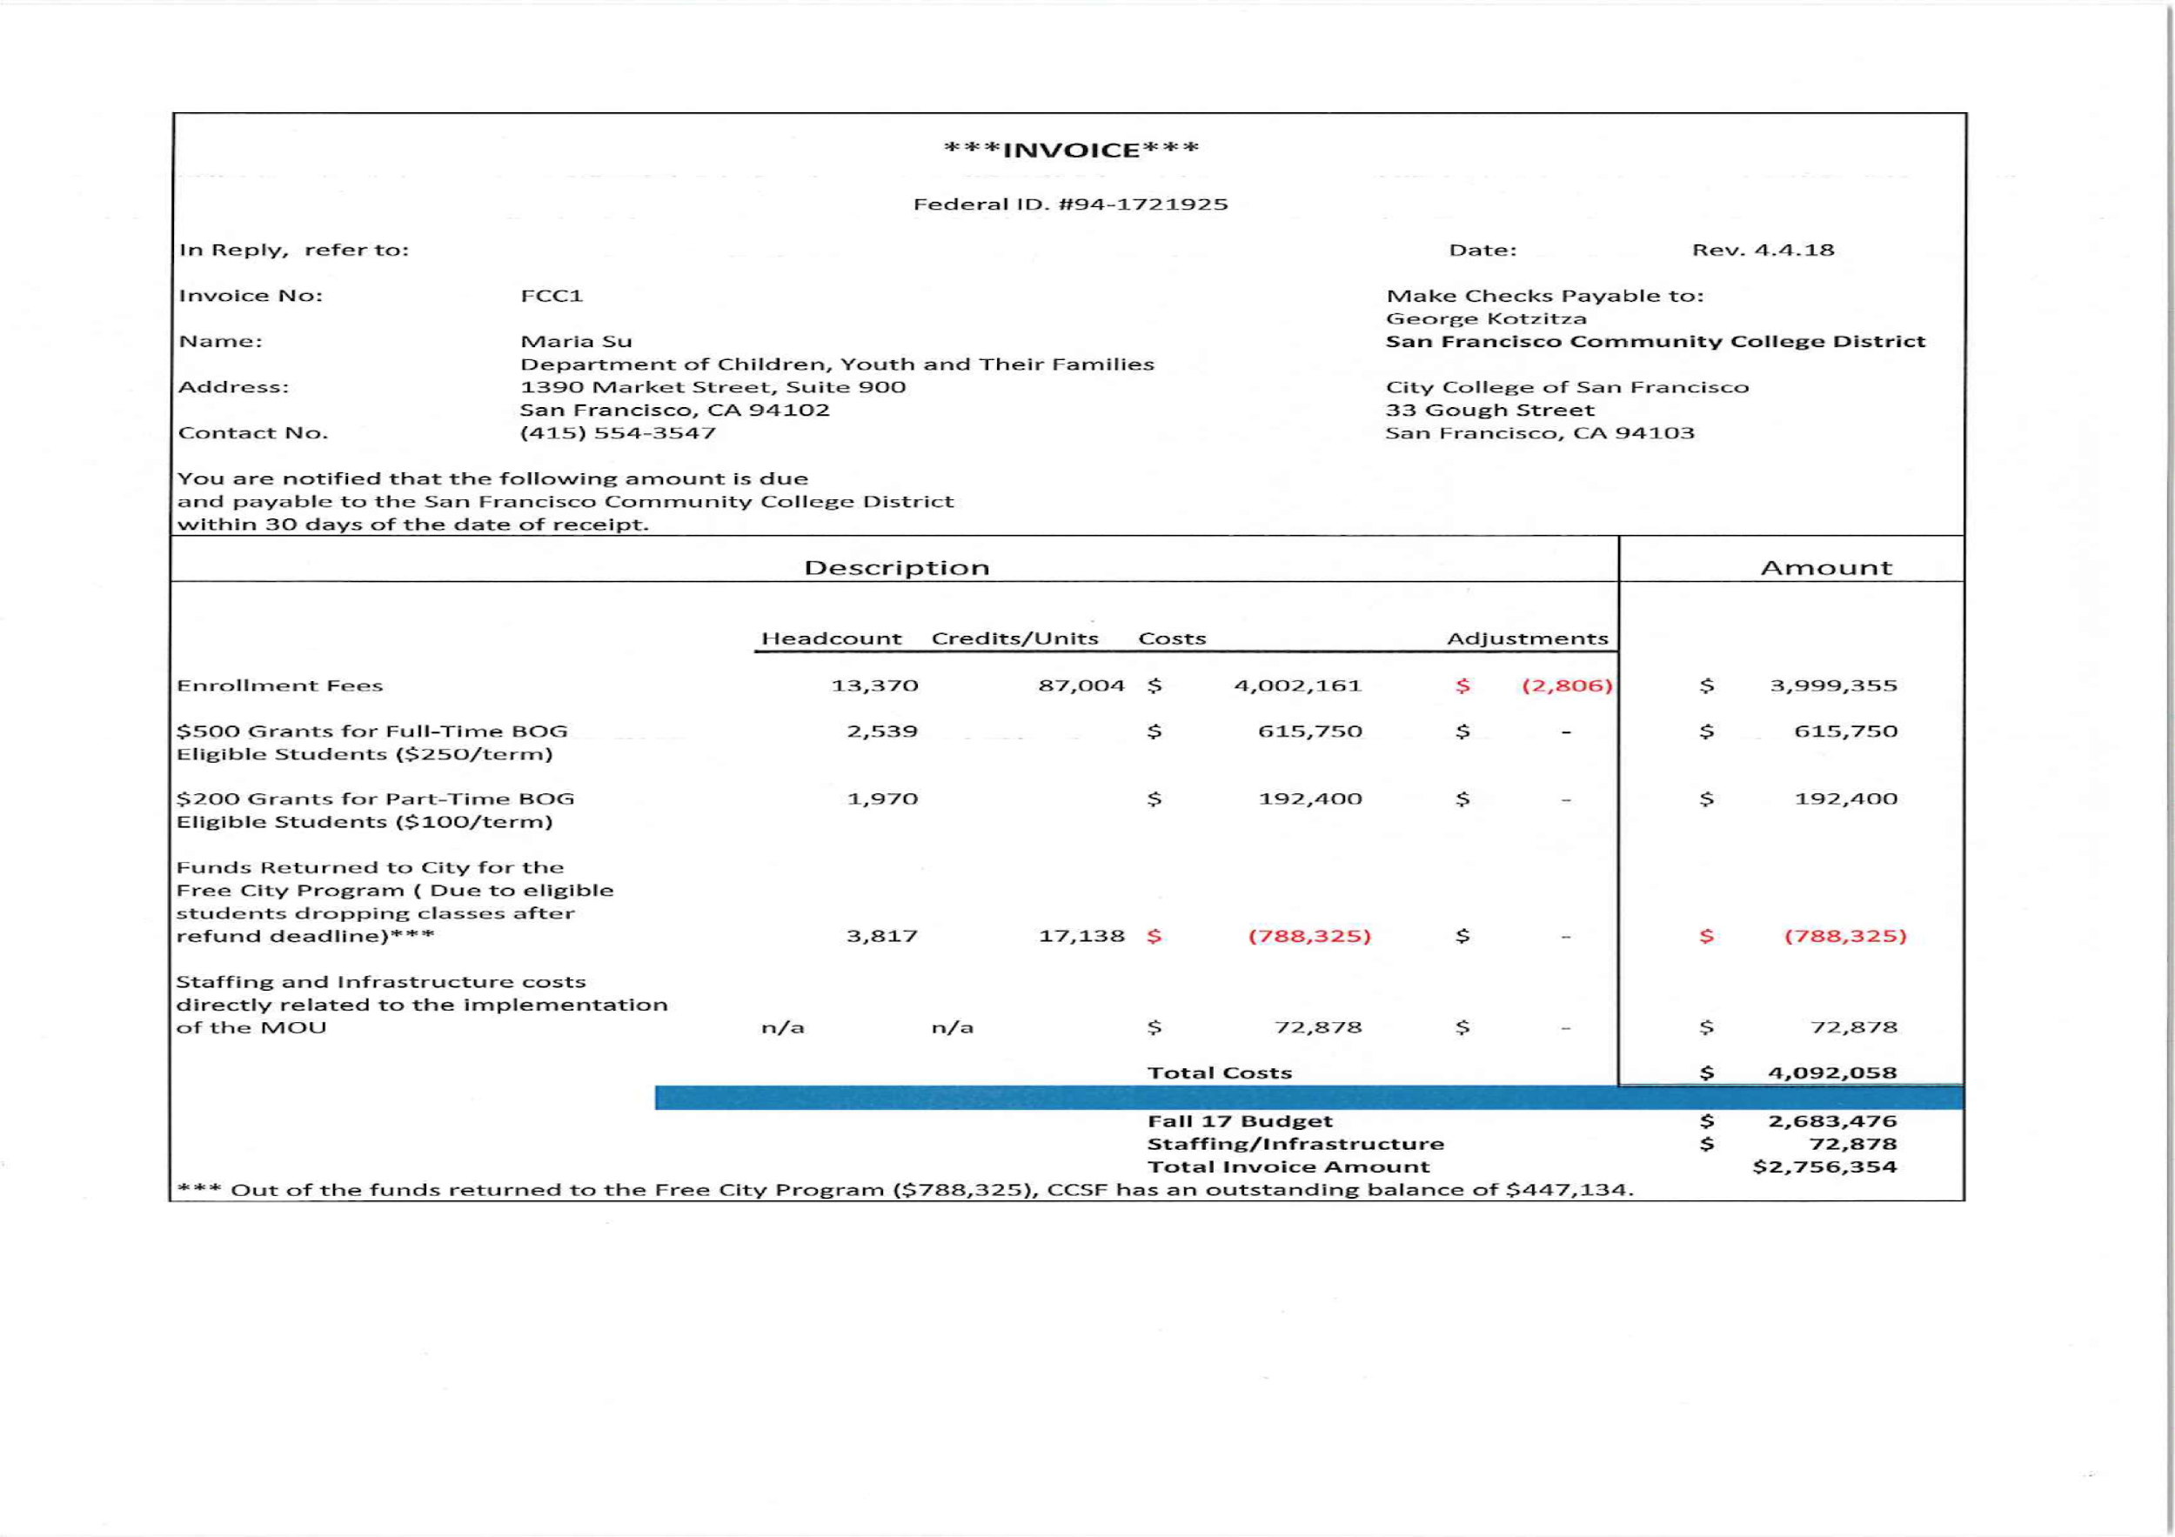

Spring 2018 Invoice
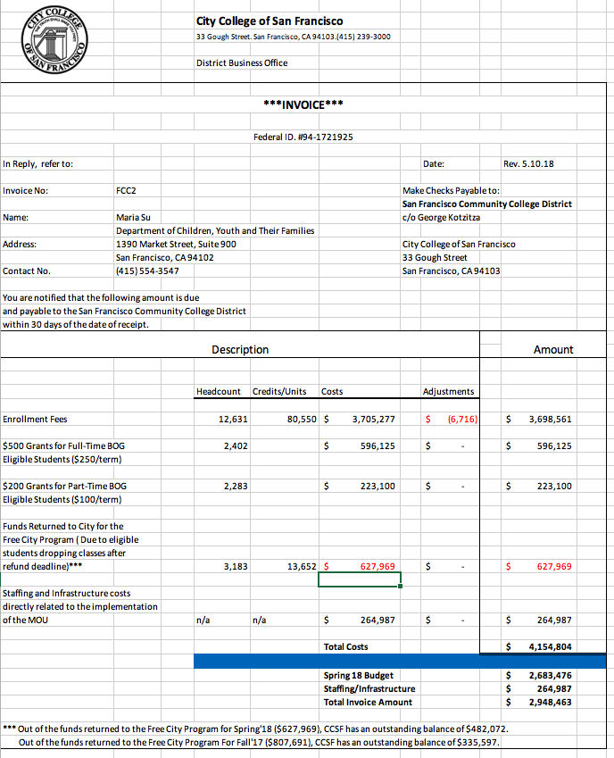
[From Jay Liao’s Total Cost v. Invoice Excel document]

Fall 2017 Invoice

Invoice 1
- First invoice received was an estimate. No information on credits was provided to confirm enrollment fee amounts.
- Headcount information did not match stipend cost information
- For example, for Full-Time BOG students, the initial enrollment count was 4,213 students. 4,213 x $250 is $1,053,250. However the Gross Cost stated in the invoice was $597,375.

Fall Invoice Interations | Invoice 1: Received 12/8/17
 | Headcount | Credits | Cost
Enrollment Fees | 9,705 | N/A | $1,854,743
$250 Grant for Full-Time BOG ($500 for full year) | 4,213 | N/A | $1,027,125
$100 Grant for Part-Time BOG ($200 for full year) | 4,728 | N/A | $459,250
Funds Returned to City for Free City Program | 4,957 | N/A | -$435,459
Staffing and Infrastructure Costs |  |  | $63,935
Total Cost |  |  | $2,969,594
Budget |  |  | $2,683,476
Staffing/Infrastructure
Invoice Amount |  |  | $2,969,594

Invoice 2

- Second invoice received with more backup documentation, however costs calculations were still not entirely clear.
- Calculations for enrollment fees are based on average credits per student, but this estimate cannot be verified by DCYF based on information given.
- Number of students in Invoice and the number of students used in calculations for stipend amount differs with no explanation.
- MOU requires City College to provide data on the number of credits taken by each student, and to include the number of eligible students who drop before the refund deadline, drop after the refund deadline, and after the Census. This information was not provided.

Invoice 2: Received 1/31/18
Headcount | Credits | Cost
7,315 | N/A | $2,624,622
2,048 or 3,803 | N/A | $950,750
5,266 or 9,780 | N/A | $978,000
3,847 | N/A | -$798,238
 |  | $69,947
 |  | $3,825,081
 |  | $2,683,476
 |  | $3,825,081

Invoice 3

- In third invoice, enrollment fee calculations are shown to be based clearly on total credits, but an adjustment column is added, which adjusts headcount rather than credits, making it unclear how final cost is calculated.
- Grant amounts are unclear. Headcount still does not match stipend cost information, no clarity on how cost is calculated.

Invoice 3: Received 2/15/18
Headcount | Credits | Cost
10,564 | 87,004 | $3,999,355
2,587 | 33,545 | $620,792
2,157 | 15,767 | $202,250
3,817 | 17,138 | -$788,325
 |  | $72,878
 |  | $4,106,950
 |  | $2,683,476
 |  | $4,106,950

Invoice 4

Final invoice methodology matches third invoice, so enrollment costs and grant amounts not verifiable

DCYF did not agree to the total cost amount, but determined that there was sufficient evidence of costs exceeding the total budgeted amount that the payment for $2.8 million was made.

Invoice 4: Received X/XX/18
Headcount | Credits | Cost
10,564 | 87,004 | $3,999,355
2,539 |  | $615,750
1,970 |  | $192,400
33,817 | 17,138 | -$788,325
 |  | $72,878
 |  | $4,092,058
 |  | $2,683,476
 |  | $72,878
 |  | $2,756,354

Spring 2018 Invoice

Spring Invoice | Received XX/X/18
 | Headcount | Credits | Cost
Enrollment Fees | 5,915 | 80550 | $3,698,561
$250 Grant for Full-Time BOG ($500 for full year) | 2,402 |  | $596,125
$100 Grant for Part-Time BOG ($200 for full year) | 2,283 |  | $223,100
Funds Returned to City for Free City Program | 3,183 | 13652 | -$627,969
Staffing and Infrastructure Costs |  |  | $264,987
Total Cost |  |  | $4,154,804
Budget |  |  | $2,683,476
Staffing/Infrastructure |  |  | $264,987
Invoice Amount |  |  | $2,948,463
Spring Invoice matches methodology of final Fall Invoice.

